SENTIMENT ANALYSIS OF STUDENT FEEDBACK USING MACHINE LEARNING AND NATURAL

LANGUAGE PROCESSING

A Thesis Presented to the Faculty, College of Computer Studies
Laguna State Polytechnic University
Los Baños Campus
Los Baños Laguna

In partial fulfilment of the requirement for the degree
Bachelor of Science in Computer Science
Specialized in Intelligence Systems

ALDRIDGE RAINHART C. ELUMACAS
VERGIL D. ROSARIO
KIEAN R. LAPITAN

MARIBEL V. CARDONA

JUNE 2026

APPROVAL SHEET

The thesis entitled “SENTIMENT ANALYSIS OF STUDENT FEEDBACK USING MACHINE LEARNING AND NATURAL LANGUAGE PROCESSING” prepared and submitted by Aldridge Rainhart C. Elumacas, Kiean R. Lapitan, and Vergil D. Rosario in partial fulfillment of the requirements for the degree Bachelor of Science in Computer Science specialized in Intelligent Systems, is hereby recommended for approval and acceptance.

MARIBEL V. CARDONA
Adviser

Approved and Accepted by the Committee on Oral Examination with a grade of ___.

GENE MARCK B. CATEDRILLA CAROLINA R. JOVAL, MAEd
Member Member

JHOCO S. MILLANES JEFFERSON L. LERIOS, DIT
Member Member

Accepted as partial fulfillment of the requirements for the degree of Bachelor of Science in Computer Science specialized in Intelligent Systems.
LOYD S. ECHALAR, DIT
Associate Dean, College of Computer Studies

OFELIA B. MANINGAS, EdD. __________________
Chairperson, Research and Development Office Date Signed

RESEARCH CONTRIBUTION NO.

ACKNOWLEDGEMENT
The researchers extend their appreciation to the administration of Laguna State Polytechnic University–Los Baños Campus, particularly University President Dr. Mario R. Briones and OIC Campus Director Engr. Manuel Luis R. Alvarez, for their support of academic research initiatives.
Special thanks are extended to the College of Computer Studies, led by Associate Dean Dr. Loyd S. Echalar, for granting permission to conduct the data collection for this study. The researchers also express their sincere gratitude to their adviser, Prof. Maribel V. Cardona, for her guidance, expertise, and support throughout the research.
Appreciation is also extended to the panel members, Prof. Gene Marck B. Catedrilla, Prof. Carolina R. Joval, and Prof. Jhoco S. Millanes, for their constructive comments and recommendations that significantly improved the quality of this research.
The researchers are deeply thankful to their families and friends for their encouragement, understanding, and continuous support, which made the completion of this research possible. The Researchers
DEDICATION
This thesis is dedicated to the authors’ families, whose unwavering support, sacrifices, and encouragement made the completion of this study possible. Their guidance and continued belief in the authors’ abilities served as a strong foundation throughout the academic journey.
Mr. Gilbert S. Elumacas and to Mrs. Noemi C.
Mr. Virgilio Rosario and Mrs. Gloria Rosario
Mrs. Eva R. Lapitan and Pablo D. Lapitan Jr.
The authors also dedicate this work to their friends, whose constant encouragement, understanding, and shared experiences provided motivation during challenging times.
A special dedication is extended to Ms. Dania Marie Bautista, the partner of the group leader Mr. Elumacas, whose patience, encouragement, and emotional support contributed significantly to his perseverance and personal growth throughout the completion of this research. Her presence and support are sincerely appreciated and valued.

A.R.C.E
K.R.L
V.D.R
ABSTRACT
Sentiment analysis of student feedback plays a vital role in understanding learners’ perceptions and improving academic services. This study developed and evaluated a sentiment analysis system for classifying student feedback at Laguna State Polytechnic University–Los Baños Campus into positive, neutral, and negative categories using deep learning and natural language processing techniques. A total of 241 manually annotated student feedback responses were collected, pre-processed, and augmented to address data scarcity and class imbalance. A stratified train–test split was applied to preserve sentiment distribution. Two sentiment classification approaches were implemented: a fine-tuned DeBERTa transformer model and a stacked ensemble model composed of a K-Fold DeBERTa ensemble, Support Vector Machine, and LightGBM classifiers with Logistic Regression as the meta-classifier. Model performance was evaluated using accuracy, precision, recall, F1-score, confusion matrices, and statistical significance testing. The stacked ensemble model achieved an accuracy of 93.79%, demonstrating strong and balanced performance across all sentiment classes. Statistical analysis indicated that no significant difference in performance existed between the stacked ensemble and the fine-tuned DeBERTa model. Despite the slightly lower accuracy, the study recommended the use of the stacked ensemble model due to its robustness, complementary learning architecture, and reliability in capturing diverse sentiment patterns in localized educational feedback. These findings supported the applicability of ensemble-based approaches for data-driven decision-making in educational institutions.
Keywords: Sentiment Analysis, Natural Language Processing, Machine Learning, DeBERTa, Transformers, Stacked Ensemble, Student Feedback.
TABLE OF CONTENTS

Preliminaries Page

Title Page i
Approval Sheet ii
Acknowledgement iii
Dedication iv
Abstract v
Table of Contents vi
List of Tables viii
List of Figures ix
Definition of Terms x

CHAPTER
I INTRODUCTION
Background of the Study 1
Statement of the Problem 2
Conceptual Framework of the Study 4
Objectives of the Study 5
Significance of the Study 5
Scope and Limitation 7
II REVIEW OF RELATED LITERATURE AND STUDIES
Related Literature 9
Synthesis and Relevance of the Study 14
Related Literature Matrix 15
Theoretical Framework 19
III METHODOLOGY
Study Area 20
Research Design 21
Population and Sampling 21
Data Collection 21
Dataset 22
Sample of the Original Student Feedback Dataset 22
Data Preparation and Pre-processing 23
Dataset Splitting 25
Model Architecture 25
Device Requirements 26
Software 27
Hardware 28
Study Procedure 29
Architecture Diagram 30
Model Development 32
Hyperparameters of the Model 34
Evaluation Metrics and Validation 35
Statistical Significance Testing 35
System Implementation 36
Ethical Considerations 38
Limitations 39

IV RESULT AND DISCUSSIONS
Data Collection 40
Data Preprocessing and Feature Engineering 42
Exploratory Data Analysis 43
Baseline Model Performance of Fine-tuned DeBERTa 46
Proposed Model Stacked Ensemble Classifier 47
Cross-Validation and Confidence Intervals 48
ROC-AUC Analysis 49
Computational Resource Efficiency 50
Comparative Analysis and Statistical Significance 50
Model Calibration Analysis 51
Ablation Study 52
McNemar’s Test 53
Qualitative Error Analysis 54
Model Interpretability: The Black Box Challenge 56
Discussion of Findings and Broader Implications 56
V SUMMARY, CONCLUSION, AND RECOMMENDATIONS

Summary of Findings 58
Conclusions 59
Limitations of the Study 60
Recommendations 62
REFERENCES 64
APPENDICES 68

Appendix A. Request Letter 69
Appendix B. Evaluation Form 71
Appendix C. Survey Questionnaire 77
Appendix D. Dataset Summary and Label Distribution 79
Appendix E. Relevant Source Code 81
Appendix F. Comparison of Fine-tuned and Ensembled 84
Appendix G Ensemble Model Training Curve 86
Appendix H. Fine-Tuned Model Training Curve 88
Appendix I. User Manual 90
Appendix J. Curriculum Vitae 92
Appendix K. Publishable Paper (IEEE format) 96
Appendix L Plagiarism Checker 103
Appendix M Grammar Checker 105

LIST OF TABLES
Table Title Page
1 Literature Matrix 15
2 Sample from Original Dataset 23
3 Examples of Text Normalization 24
4 Sentiment Labelling Criteria 24
5 Minimum Device Requirements for System Use 27
6 Specific Hardware Configuration 29
7 Training Procedure and Environment Specifications 33
8 Model Configuration Parameters 35
9 Total Number of CCS Students 42
10 Original Training Set 43
11 Classification Report of Baseline 47
(Fine-tuned DeBERTa)
12 Classification Report of Proposed 48
(Stacked Ensemble) Model
13 Per-Fold Performance and Confidence Intervals 49
14 One-vs-Rest ROC-AUC Scores 49
15 Runtime and Resource Statistics 50
16 Head-to-Head Performance Comparison of Models 51
17 Calibration Comparison (Brier Score) 52
18 Ablation Summary of Component Models 52
19 McNemar’s Test Contingency Table 53
20 Misclassifications and Model Disagreements 55

LIST OF FIGURES
Figure Title Page
1 Conceptual Framework 4
2 Theoretical Framework 19
3 L.S.P.U – Los Baños Campus 20
4 Architecture Diagram 30
5 Data Gathered through Google Form 41
6 Original Label Distribution 44
7 Training Dataset After Augmentation 45
8 Text Length Distribution 45
9 Word Cloud of Student Feedback 46
10 Confusion Matrix of the Stacked Ensemble 48

Definition of Terms
Artificial Intelligence (AI) | Refers to the simulation of human intelligence processes by machines, especially computer systems, enabling them to perform tasks such as learning, reasoning, and self-correction.
Base-Learner (Level 0 Model) | In a stacked ensemble, a base-learner is one of the initial models (e.g., DeBERTa, SVM, LightGBM) trained on the original dataset. Their predictions are used as input features for the meta-learner.
Confusion Matrix | A table used to evaluate the performance of a classification model by comparing actual labels with predicted labels.
Data Augmentation | A preprocessing technique used to artificially expand the training dataset by generating variations of existing text (e.g., synonym replacement, back-translation, paraphrasing). This helps prevent overfitting and improves the model’s ability to generalize to unseen feedback.
Data Splitting | The process of dividing a dataset into separate parts for model training and evaluation. It typically involves splitting data into training, validation, and testing sets. This ensures the model is properly trained, fine-tuned, and tested for accuracy on unseen data.
DeBERTa (Decoding-enhanced BERT with Disentangled Attention) | An advanced transformer model developed by Microsoft that improves upon BERT and DeBERTa by separating content and position information in its attention mechanism.
Early Stopping | A regularization technique used during training to prevent overfitting. The training process stops automatically when performance on a validation set stops improving, ensuring the model captures general patterns rather than noise.
Ensemble Learning | A machine learning technique where multiple models are trained to solve the same problem and their predictions are combined to achieve better performance than any single model alone.
Fine-Tuning | The process of taking a pre-trained model (like DeBERTa) and continuing its training on a smaller, domain-specific dataset to adapt it to a particular task.
Focal Loss | A specialized loss function used in classification tasks that is designed to address class imbalance. It down-weights the loss assigned to well-classified examples, allowing the model to focus more on learning difficult or rare examples.
Hyperparameter Tuning | The process of optimizing the configuration settings of a machine learning model (such as learning rate, batch size, number of epochs) to improve its performance.
K-Fold Cross-Validation | An evaluation technique where a dataset is split into 'K' subsets (folds). The model is trained K times, each time using a different fold as the validation set and the remaining K-1 folds as the training set. This provides a more robust estimate of model performance.
Laguna State Polytechnic University – Los Baños Campus (LSPU-LBC) | The state university in the Philippines where the study is conducted, focusing on leveraging technology for academic and institutional improvement.
Lemmatization | The process of breaking down text into smaller units, such as words or subwords, for easier analysis.
LightGBM | A high-performance, open-source gradient boosting framework that uses tree-based learning algorithms. It is known for its speed and efficiency.
Machine Learning | A branch of artificial intelligence (AI) that focuses on building algorithms and models capable of learning patterns from data and making predictions or decisions without being explicitly programmed.
Macro-Averaged Scores | A method of averaging performance metrics (such as precision, recall, and F1-score) across all classes (positive, neutral, negative) by treating each class equally, regardless of their frequency in the dataset. This is especially useful in imbalanced datasets to ensure fair evaluation across all sentiment categories.
Meta-Learner (Level 1 Model) | In a stacked ensemble, the meta-learner is the final model (e.g., Logistic Regression) that is trained on the predictions of the base-learners to make the ultimate classification.
Natural Language Processing (NLP) | A branch of artificial intelligence that focuses on the interaction between computers and human language, enabling machines to understand, interpret, and generate human language.
Pre-trained Model | A model that has been previously trained on a large, general-purpose dataset. In this study, DeBERTa is a pre-trained model that is later fine-tuned for the specific task of sentiment analysis.
Sentiment Analysis | The computational study of opinions, sentiments, emotions, and attitudes expressed in text, aiming to determine the sentiment polarity (positive, neutral, or negative)
Stacked Generalization (Stacking) | An advanced ensemble learning technique that involves training a meta-learner on the predictions generated by multiple base-learner models to make a final, more accurate prediction.
Stopword Removal | A preprocessing step that removes common words (e.g., "the," "is," "and") that are unlikely to be useful in text analysis.
Support Vector Machine (SVM) | A supervised machine learning algorithm used for classification and regression tasks. It works by finding the optimal hyperplane that best separates data points of different classes in a high-dimensional space.
Term Frequency-Inverse Document Frequency (TF-IDF) | A statistical measure used to evaluate the importance of a word to a document relative to a collection of documents.
Tokenization | The process of breaking down text into smaller units, such as words or sub-words, for easier analysis.
Transformer | A deep learning model architecture that uses self-attention mechanisms to process sequential data, enabling parallel computation and long-range dependency modelling.
Transfer Learning | A machine learning theory and method where a model developed for a first task is repurposed as the starting point for a model on a second, related task.
Vectorization | The process of converting textual data into numerical representations so that machine learning models can process it.

CHAPTER 1

INTRODUCTION
Background of the Study
Student feedback is a vital source of information for assessing the quality of instruction, academic services, and institutional support in higher education. Unlike numerical ratings, open-ended feedback allows students to express nuanced opinions, concerns, and experiences related to their academic environment. However, as the volume of such qualitative feedback increases, manual analysis becomes time-consuming, subjective, and impractical for timely institutional decision-making.
Advancements in artificial intelligence, particularly in machine learning and natural language processing (NLP), have enabled the automated analysis of large-scale textual data. Sentiment analysis, a subfield of NLP, facilitates the classification of text based on expressed sentiment, typically categorized as positive, negative, or neutral. Recent developments in transformer-based architectures have significantly improved sentiment classification accuracy by capturing contextual and semantic relationships within text.
At Laguna State Polytechnic University–Los Baños Campus (LSPU-LBC), student feedback is regularly collected but remains largely underutilized due to the absence of an automated sentiment analysis system. This limitation reduces the institution’s ability to promptly identify recurring concerns and respond effectively to student needs. Consequently, there is a need for a reliable and context-aware sentiment analysis system capable of processing student feedback accurately and efficiently.
This study addresses this need by developing and evaluating machine learning-based sentiment analysis models for student feedback at LSPU-LBC. Specifically, it investigates the performance of a stacked ensemble architecture in comparison with a strong transformer-based baseline model, with the aim of identifying an effective approach for automated sentiment classification in an educational context.
Statement of the Problem
Educational institutions such as Laguna State Polytechnic University–Los Baños Campus generate a substantial volume of qualitative student feedback that contains valuable insights into students’ academic experiences and institutional services. However, the manual analysis of this feedback is labour-intensive, prone to subjective interpretation, and unable to provide timely results for administrative action. As a result, critical sentiments expressed by students may remain unrecognized or inadequately addressed.
While recent advancements in natural language processing offer potential solutions to this challenge, determining the most effective modelling approach for sentiment classification in a localized educational context remains an open problem. In particular, it is necessary to examine whether combining multiple machine learning models through an ensemble architecture yields better performance than relying on a single fine-tuned transformer model.
This research specifically seeks to answer the following questions:
- How can a stacked ensemble architecture composed of a K-Fold DeBERTa ensemble, Support Vector Machine (SVM), and LightGBM base models with a Logistic Regression meta-classifier be designed and implemented for classifying student feedback sentiment?
- How does the stacked ensemble model perform in classifying student feedback into positive, neutral, and negative sentiments based on accuracy, precision, recall, and F1-score?
- How does the performance of the stacked ensemble model compare with that of a single fine-tuned DeBERTa transformer baseline?
- How can the superior-performing model be implemented into a functional prototype to demonstrate its practical applicability for institutional stakeholders?
Conceptual Framework of the Study
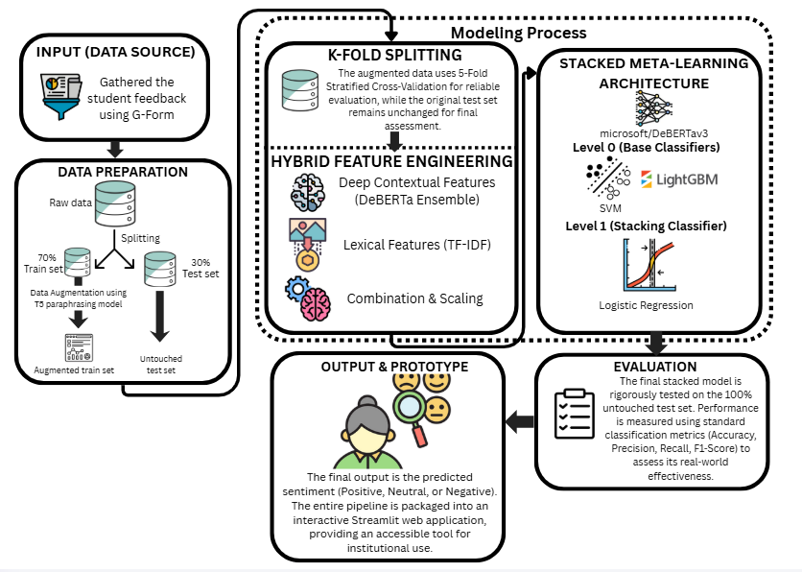
The conceptual framework of the study illustrates the overall flow and structure of the proposed sentiment analysis system using an Input–Process–Output (IPO) model, which serves as a guide for the systematic design, implementation, and evaluation of machine learning and natural language processing techniques applied to student feedback sentiment classification. The input component consists of raw, open-ended student feedback collected through an online survey administered to the College of Computer Studies at Laguna State Polytechnic University–Los Baños Campus, with responses annotated into three sentiment categories—positive, neutral, and negative—forming the foundational data for analysis. The process component encompasses multiple stages, beginning with data preprocessing procedures such as text cleaning and normalization to ensure data quality and consistency. To mitigate data scarcity and address class imbalance, text augmentation techniques are applied exclusively to the training data, followed by a stratified division of the dataset into training and testing sets to preserve sentiment distribution. Feature representation is generated using transformer-based embeddings, enabling the models to capture contextual and semantic information from the text. Two modelling approaches are implemented: a stacked ensemble model integrating a K-Fold DeBERTa ensemble with Support Vector Machine (SVM) and LightGBM classifiers and a Logistic Regression meta-classifier, and a fine-tuned DeBERTa transformer baseline model. Model performance is assessed using standard evaluation metrics, including accuracy, precision, recall, and F1-score, to ensure reliable and objective comparison. The output of the framework is a validated sentiment analysis system capable of accurately classifying student feedback into positive, neutral, or negative sentiments, complemented by a functional prototype that demonstrates real-time applicability for institutional feedback analysis and supports informed, data-driven decision-making, thereby maintaining coherence between the system design and the study’s research objectives.
Figure 1. Conceptual Framework
Objectives of the Study
The primary objective of this study is to develop and evaluate an automated sentiment analysis system for student feedback using machine learning techniques. Specifically, this study aims to:
- Design and implement a stacked ensemble sentiment analysis model combining a DeBERTa transformer ensemble with classical machine learning models (SVM and LightGBM) and a Logistic Regression meta-classifier.
- Develop and fine-tune a single DeBERTa transformer model to serve as a baseline for performance comparison.
- To validate the generalization capability and reliability of the stacked ensemble model and the baseline model by assessing their performance on an unseen test dataset using standard classification metrics.
- To evaluate the comparative effectiveness of the stacked ensemble and baseline models through statistical performance analysis, including a paired t-test, and to assess the suitability of the superior model for deployment in a functional sentiment analysis prototype for LSPU–Los Baños Campus.
Significance of the Study
This research develops an advanced sentiment analysis system using a methodologically sophisticated stacked ensemble model. A primary limitation of real-world institutional data is typically its smaller size and class imbalance. To overcome this, this research does not focus on carefully fine-tuning a single model, and focuses instead on pooling the best aspects of multiple paradigms. The architecture harnesses the deep contextual comprehension of a DeBERTa transformer, the solid decision boundaries offered from the classical models like SVM, and the ability to run computationally lightweight models like LightGBM.
This approach was deliberately selected to promote improved performance and generalizability by training a meta-classifier on the outputs of these disparate models; thus, the resulting system can provide more accurate and reliable predictions than can be expected from any one model. The methodological rigor is strengthened by utilizing a completely independent hold-out test set, and an evaluation of the ensemble is conducted against a strong baseline to ensure unbiased assessment of the ensemble's true performance as much as possible. To address class imbalance and overfitting, advanced methods, including a Focal Loss function and K-Fold cross-validation, are utilized in order to produce a more robust and equitable predictive system.
The study contributes to UNESCO's Sustainable Development Goal 4: Quality Education, which calls for inclusive, equitable, and quality education. There has been a call by UNESCO for the potentials of emerging technologies, including Artificial Intelligence, to be harnessed for learning analytics, student feedback systems, among others. This study, in its implementation of this advanced, tuned DeBERTa model for automated sentiment analysis, directly contributes to financing UNESCO's work of establishing "smart education systems" that are adaptive, inclusive, and evidence-informed in a bid to enhance responsiveness and service quality in higher education.
For the University Administration. The findings provide a systematic approach for analysing student feedback, enabling administrators to identify trends, recurring concerns, and areas for improvement through data-driven insights.
For Academic Staff and Faculty. The system can support reflective teaching practices by offering summarized sentiment trends related to instructional methods and classroom experiences.
To the Students. By enabling more responsive analysis of feedback, the study strengthens the role of student voices in institutional decision-making and promotes a more student-centered academic environment.
For Educational Policy Makers. The study demonstrates how artificial intelligence can be applied to support evidence-based decision-making aligned with quality education initiatives.
For Curriculum Developers. Insights gathered through sentiment analysis could bring out distinct strengths and pain points in current courses, informing curriculum adjustments that are data-driven and responsive to student feedback. This would create further enhancements to course design and be better at meeting the needs of the students.
For Future Researchers. This research contributes to the growing body of literature on sentiment analysis in education and provides a reference framework for applying transformer-based and ensemble models in similar contexts.
Scope of the Study
This study focuses on student feedback collected from the College of Computer Studies at Laguna State Polytechnic University–Los Baños Campus. The dataset consists of open-ended survey responses obtained through an online data collection instrument. The research is limited to sentiment classification into three categories: positive, neutral, and negative.
Moreover, the researchers identifying themselves as part of the CCS community provided a clear methodological advantage. When researchers adopt the "insider" or "emic" perspective, they have an embedded, nuanced understanding of the context, commonly used language, and any potentially contentious aspects of the feedback. Familiarity with the context of the feedback and use of familiar language greatly aids in correctly interpreting the finer points of the data and robustly confirming the performance of the model, an outcome described as an advantage of insider research (Dwyer & Buckle, 2009). Thus, utilizing an accessible convenience sample, in this instance, from the CCS department, provides a very practical and rigorous method for this methodological study. In keeping with a methodological soundness of "split-first" study design, collectively endorsed responses were segregated into a file for training and into the file that was not used for any aspect of the modeling. Thus, the split-first file yielded very important significance to avoid potential data leakage.
Limitations of the Study
A primary methodological limitation of this study is its reliance on convenience sampling from the College of Computer Studies (CCS). This non-probability approach may introduce sampling bias, as respondents may not fully represent perspectives within CCS or other institutions. Consequently, the observed sentiment distributions and model performance cannot be considered statistically representative or generalizable beyond this sample.
CHAPTER 2

REVIEW OF RELATED LITERATURE AND STUDIES

In this chapter, we will review the literature that has formed the basis of sentiment analysis of student feedback, and place our study in relation to established practices, theories, and the current opportunities and challenges for ML and NLP. Literature review has been organized in a logically sequenced manner, starting with theory, followed by application, and concluding with challenges. Together this literature will provide a theoretical rationale for the methodology from which our study emerged.
Annotation Guidelines in Sentiment Analysis Dataset
A success for any supervised sentiment analysis model is essentially based on the quality and consistency of its annotated training data. The literature agrees to a three-label classification system: positive, negative, and neutral, which could be reliable and standard for sentiment analysis tasks; Mohammad 2016; Giachanou & Crestani, 2016. While the determination of clearly positive or clearly negative statements generally presents no problem, a challenge mentioned in many studies is the exact and consistent definition of what constitutes a 'neutral' category.
Thus, there are clear guidelines on this by researchers. Primarily, the neutral label is reserved for objective or factual statements without any explicit or implicit sentiment. A statement will be regarded as neutral if, for example, it says, "The restaurant has a parking lot," as this simply describes a feature without giving an opinion (Pontiki et al., 2016). This is very important in distinguishing different sentiments so that the model does not make an inference for sentiment when actually there is none (Krouska, Troussas, & Virvou, 2016).
Moreover, in situations such as student feedback, the neutral category also specifies the questions or truncated suggestions that are not to be interpreted as negative. For instance, Mohammad (2016) points out that a question like "Can you add more examples?" should be placed in the neutral category, while saying, "It was confusing without examples," is negative. This is an important distinction to make in order to properly interpret what the user is actually trying to communicate.
In summary, the construction of a high-quality, or "golden standard", dataset depends on having clear and pre-defined rules for annotators (Giachanou & Crestani, 2016). Reliability of the annotations is often evaluated through inter-annotator agreement (IAA) where a high level of agreement would lead us to conclude that the guidelines used for coding were reliable and consistently applied (Al-Twairesh, Al-Negheimish, & Al-Khalifa, 2016). Thus, again in consideration of these established best practices, we adopted a total of three labels for annotating data, and worked to define a disjunction category in order to promote an effective and efficient sentiment analysis model.
Sentiment Analysis in Educational Contexts
Sentiment analysis has been increasingly applied in educational research to analyze students’ opinions, attitudes, and experiences expressed through textual feedback. Previous studies have shown that sentiment classification of student feedback can support institutional decision-making by identifying trends related to teaching effectiveness, course delivery, and academic services (Bakharia et al., 2016; Romero & Ventura, 2020).
Early approaches to educational sentiment analysis relied on classical machine learning algorithms such as Naïve Bayes, Support Vector Machines (SVM), and Logistic Regression using handcrafted linguistic features (Pang & Lee, 2008; Medhat et al., 2014). While these methods achieved moderate success, their performance was limited by feature engineering constraints and an inability to capture contextual meaning in text.
Recent studies demonstrate that deep learning and transformer-based approaches significantly outperform traditional models in educational sentiment analysis tasks by capturing semantic and contextual nuances commonly present in student feedback (Cambria et al., 2017; Sun et al., 2019). However, many existing studies utilize publicly available or generalized datasets, limiting their applicability to institution-specific contexts.
NLP and Sentiment Analysis in the Philippine Context
While the general ideas of sentiment analysis are universal, their application within the Philippine context presents unique challenges and opportunities essential to this study. Local research in NLP has focused on code-switching, specifically between English and Filipino, referred to colloquially as "Taglish," an issue that remains common in informal text and social media. Research emphasizes how analysing Filipino sentiments is quite challenging due to non-standard spellings and the ever-flowing grammatical structure of Taglish that challenges even a standard NLP model; Roxas et al., 2018; Ong & Cabarrubias, 2021
A survey of the current state-of-the-art in Filipino sentiment analysis confirms that most research so far has concentrated on publicly available data from social media platforms such as Twitter and Facebook to analyze public opinion (Balahadia et al., 2020). This has real value, but it also means that existing models and techniques are optimized for short, informal, and often public-facing text.
Hence, there is a noticeable literature gap on the application of these state-of-the-art NLP models to the educational domain in the Philippines. The specific linguistic peculiarities of student feedback, which may range from formal to informal and include academic jargon with Taglish, have not been explored yet. This paper contributes toward this gap by applying a state-of-the-art transformer model to a dataset collected from a Philippine university, hence answering the call for more domain-specific and contextually aware NLP research in the local setting.
Transformer-Based Models for Sentiment Analysis
Transformer architectures have become the dominant paradigm in natural language processing due to their ability to model long-range dependencies through self-attention mechanisms (Vaswani et al., 2017). Bidirectional Encoder Representations from Transformers (BERT) introduced contextualized word embeddings that significantly improved performance across various NLP tasks, including sentiment analysis (Devlin et al., 2019).
Subsequent transformer variants further enhanced representational capacity. DeBERTa (Decoding-enhanced BERT with disentangled attention) improved upon BERT by separating content and positional information in its attention mechanism, resulting in stronger contextual modelling and improved performance on downstream tasks (He et al., 2021). Empirical studies have reported that fine-tuned DeBERTa models outperform earlier transformer architectures in sentiment classification tasks, particularly in low-resource and domain-specific settings (Liu et al., 2022).
Transfer learning plays a crucial role in transformer-based sentiment analysis, allowing models pre-trained on large corpora to be adapted to smaller, domain-specific datasets through fine-tuning (Howard & Ruder, 2018; Devlin et al., 2019). This approach is especially beneficial in educational contexts, where labelled data is often limited.
Ensemble Learning in Sentiment Classification
Ensemble learning integrates multiple predictive models to improve classification accuracy and robustness by leveraging the strengths of individual learners (Dietterich, 2000). In sentiment analysis, ensemble approaches have been shown to reduce variance and improve generalization performance compared to single-model architectures (Polikar, 2006).
Recent research has explored hybrid ensemble architectures that combine transformer-based models with classical machine learning classifiers such as SVM and gradient boosting algorithms. These hybrid approaches aim to capture both deep contextual representations and statistical patterns in textual data (Zhou, 2012; Wang et al., 2021). While ensemble models often demonstrate performance gains, their effectiveness depends on dataset characteristics, model diversity, and task complexity.
Moreover, ensemble methods introduce additional computational overhead, and several studies report that strong single-transformer baselines may perform competitively or even outperform complex ensembles in certain domain-specific sentiment analysis tasks (Raffel et al., 2020; Liu et al., 2022).

Challenges in Sentiment Analysis of Student Feedback
Despite advancements in sentiment analysis, several challenges remain in analyzing student feedback. Educational texts frequently contain polite criticism, indirect expressions, and mixed sentiments, which complicate accurate sentiment classification (Thelwall et al., 2012). Additionally, class imbalance is common in educational datasets, where neutral or positive feedback often dominates (Kaur & Gupta, 2013).
Domain shift presents another challenge, as sentiment analysis models trained on general-purpose corpora may not generalize well to institution-specific language, terminology, and cultural context (Glorot et al., 2011). These challenges highlight the need for domain-adaptive modelling and localized dataset evaluation.
Synthesis and Identified Gaps in the Literature
The reviewed literature indicates that transformer-based models consistently achieve state-of-the-art performance in sentiment analysis by effectively capturing contextual semantics in text (Devlin et al., 2019; He et al., 2021). Ensemble learning has also shown potential in improving classification performance by integrating diverse modelling approaches (Dietterich, 2000; Polikar, 2006).
However, several gaps remain evident. First, limited studies have evaluated stacked ensemble architectures that combine advanced transformer models with classical machine learning classifiers specifically for educational sentiment analysis. Second, existing research largely relies on generalized or publicly available datasets, with insufficient focus on localized student feedback within Philippine higher education institutions. Third, few studies provide a direct performance comparison between complex ensemble architectures and strong single-transformer baselines in low-resource educational settings.
To address these gaps, the present study proposes a stacked ensemble sentiment analysis model integrating a K-Fold DeBERTa ensemble, Support Vector Machine, and LightGBM classifiers with a Logistic Regression meta-classifier. The study further evaluates the ensemble’s performance against a fine-tuned DeBERTa baseline using an institution-specific student feedback dataset from LSPU-LBC.
Related Literature Matrix
This table presents studies related to machine learning, NLP, and sentiment analysis in the educational context, particularly focusing on student feedback.
Table 1. Literature Matrix
Author(s) | Year | Title / Study | Algorithm | Key Findings / Contributions
 | 2014 | Sentiment Analysis for Education (SA-E) | Naïve Bayes, SVM | Demonstrated the feasibility of using machine learning algorithms for real-time educational sentiment analysis.
  Altrabsheh, Gaber, & Cocea
 | 2016
  Al-Twairesh, Al-Negheimish, & Al-Khalifa
  Arabic Sentiment Analysis: Challenges and Guidelines
  Introduced inter-annotator agreement (IAA) as a reliability measure for annotated datasets, which is essential for ensuring consistency in sentiment annotation.
 | 2016
  Balahadia et al.
  Sentiment Analysis of Filipino Social Media Data
  Identified domain adaptation as a major issue where models fail to generalize to unseen contexts.
 | 2016
  Giachanou & Crestani
  Sentiment Analysis: A Survey
  Emphasized annotation consistency and introduced guidelines for creating reliable sentiment datasets. This is key for high-quality educational datasets.
 | 2020 |  | BiLSTM, BERT
  Hajrizi & Pireva Nuçi
  Aspect-Based Sentiment Analysis in Education
  Proposed Aspect-Based Sentiment Analysis (ABSA) to extract fine-grained sentiment on specific educational aspects, useful in analyzing detailed student feedback.
Koufakou | 2021  2023 |  | SVM, Naïve Bayes, Deep Learning,  TrDeBERTa, BERT, SVMansformer
  Kastrati et al.
  Systematic Mapping of Sentiment Analysis in Education
  Comparative Study of Sentiment Analysis Models for Online Course Reviews
  Documented the evolution of sentiment analysis in education and the growing shift towards deep learning and transformer-based models.
  Found DeBERTa achieved the highest accuracy (95.5%) for educational sentiment classification, supporting the superiority of transformer models in this domain.
 | 2023 |  | Neural Machine Translation | Highlighted the importance of precise neutral-label definitions for consistent sentiment classification, which is crucial for high-quality educational sentiment datasets.
  Krouska, Troussas, & Virvou
  Comparative Evaluation of Sentiment Analysis Methods
Mohammad
  2023
  Sentiment Lexicons and Annotation Guidelines
  Defined standard sentiment categories, including the "neutral" category, and clarified its role in distinguishing objective statements from subjective ones.
 | .  2023
  Ong & Cabarrubias
  Processing Taglish Text in NLP
  Discussed the difficulty of handling Taglish and non-standard grammar in Philippine text data. This issue is particularly relevant for sentiment analysis in the Philippine educational context.
 | 2023
  Pontiki et al.
  SemEval Aspect-Based Sentiment Analysis Task
  Defined factual statements as neutral examples; set annotation benchmarks for sentiment analysis tasks, providing guidance on neutral sentiment classification.
 | 2023
  Roxas et al.
  Filipino Sentiment Analysis and Code-Switching
  Identified code-switching as a linguistic challenge for NLP in the Philippines, specifically in handling mixed-language data like Taglish in educational feedback.
 | 2023 |  | NMT (Back-Translation)
  Sennrich, Haddow, & Birch
  Neural Machine Translation for Data Augmentation
  Proposed back-translation to increase dataset diversity while retaining meaning, which can be useful in generating diverse student feedback samples for sentiment analysis.
 | 2023 |  | BERT
  Shaik et al.
  Context-Aware Sentiment Analysis in Education
  Reported that BERT handles nuanced feedback in education but struggles with bilingual (Taglish) content, a challenge for sentiment analysis in Philippine educational contexts.
 | 2023 |  | Transformer Models
  Treviso et al.
  Pre-Training and Fine-Tuning in NLP
  Described fine-tuning as the standard for domain adaptation in NLP, emphasizing the need for fine-tuning transformer models on domain-specific educational datasets.
 | 2023
  Yang et al.
  Domain Shift and Out-of-Distribution Generalization in NLP
  Reported performance degradation when models are applied to unseen or domain-specific data, highlighting the importance of domain-adaptive models for educational sentiment analysis.

Theoretical Framework
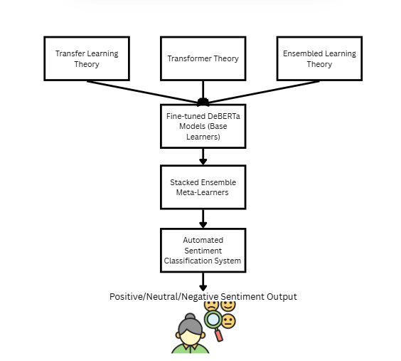
Natural Language Processing theory provides the foundation for transforming unstructured textual feedback into structured representations suitable for machine learning-based analysis (Jurafsky & Martin, 2023). Transformer architectures operationalize this theory by employing self-attention mechanisms to capture contextual relationships within text (Vaswani et al., 2017).
Figure 2. Theoretical Framework
Transfer learning theory supports the use of pre-trained language models such as DeBERTa, which are fine-tuned on domain-specific datasets to improve performance in low-resource scenarios (Howard & Ruder, 2018). Ensemble learning theory justifies the integration of multiple classifiers to enhance predictive accuracy and robustness by leveraging complementary model strengths (Zhou, 2012). Together, these theories provide a strong methodological foundation for employing a fine-tuned DeBERTa model within a stacked ensemble architecture to achieve robust sentiment classification performance despite limited and domain-specific training data.
CHAPTER 3

METHODOLOGY
Study Area
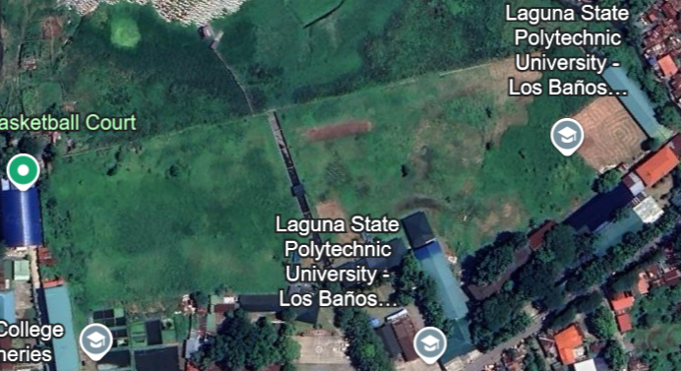
This research was conducted in the academic environment of Laguna State Polytechnic University – Los Baños Campus, an institution of higher learning committed to utilizing current and future technologies in the development of a smart, agile learning environment. Specifically, it focused on the College of Computer Studies offering two programs: Computer Science and Information Technology. The reason for the choice of this college is that it can provide a context that is highly appropriate for the research questions, with a high level of technological awareness. In this way, developing a sentiment analysis model using the feedback from students within a tech-based academic institution will make sure that the model is trained on domain-specific language, which aligns the research outcomes with the strategic goals of the institution for data-driven improvement.
Figure 3. Laguna State Polytechnic University - Los Baños Campus
Research Design
This study employed a quantitative, experimental research design focused on the development, evaluation, and comparison of machine learning models for sentiment classification of student feedback. The research emphasizes model performance analysis using standard classification metrics and does not aim to generalize findings beyond the dataset used. An applied systems development approach was adopted to demonstrate the feasibility of implementing sentiment analysis in an academic institutional context.
Population and Sampling
The student population from the College of Computer Studies served as the only source for the primary dataset used for this research. Student responses were gathered through a structured survey, and this localized dataset served as the total corpus for model training, data augmentation, and evaluation of the model's output. The localized context was important since the research utilized advanced AI techniques: Natural Language Processing and Machine Learning, two branches, to automate the evaluation of feedback given explicitly by the LSPU-LBC student population. Building and validating the model with data from its operational context was intended to turn raw-unstructured feedback into structured and actionable intelligence that could help inform data-driven educational decisions and directly contribute to the campus's vision for institutional improvement.
Data Collection
Student feedback data were collected from students enrolled in the College of Computer Studies at Laguna State Polytechnic University–Los Baños Campus through an online survey instrument. The survey consisted of open-ended questions that allowed students to freely express their opinions regarding academic experiences and institutional services. All collected responses were anonymized to ensure participant confidentiality.
Dataset
The dataset consists of 241 manually annotated student feedback entries, each labeled as positive, neutral, or negative. Annotation was performed following predefined sentiment guidelines to ensure labeling consistency. The dataset reflects real-world class imbalance typically observed in educational feedback, with neutral and positive sentiments occurring more frequently than negative sentiments. After data cleaning and annotation, 241 valid responses were retained. The dataset was divided using a 70/30 stratified split, resulting in 169 training samples and 72 test samples.
Sample of the Original Student Feedback Dataset
This table is a snapshot of our raw data and serves as an example of what our raw data looked like before cleaning and processing. It can give the reader an idea about the structure, volume, and types of feedback that were collected among the students. Such an overview gives context to the dataset and tells the reader how the data were prepared and refined afterward for analysis. Presenting the raw feedback in this form highlights the variability in language, length, and sentiment expressed by the respondents. It also demonstrates the presence of noise, inconsistencies, and informal expressions that necessitated systematic preprocessing. Moreover, this snapshot underscores the importance of careful data preparation to ensure reliable and unbiased sentiment classification. Additionally, the snapshot reflects the real-world nature of student feedback, capturing authentic expressions and diverse viewpoints. This further justifies the need for robust pre-processing techniques and advanced models to effectively handle unstructured textual data.
Table 2. Sample from Original Dataset
Feedback Text | Initial Sentiment Label
The services often feel incomplete, as if they don’t address the actual issues students face. | Positive
Some teachers don’t care even if students are clearly lost. They just move on with lessons. | Neutral
The Wi-Fi is very slow, especially during peak hours. It's difficult to get my research done | Negative
The enrollment process was okay but could be faster. | Neutral
Labs are helpful but the room is old and wasn't given any attention to renovation or improve. | Negative
Data Preparation and Pre-processing
The dataset was split into 70% for training and 30% for testing, equivalent to 169 data for training which will undergo data augmentation and 72 data will remain untouched for testing to making sure that there was a balanced sentiment distribution to preserve proportionality of positive, neutral, and negative feedback. Preprocessing steps taken on the training set included text normalization, T5-based data augmentation, and preparation of hybrid features with TF-IDF vector lexical features and contextual features using the DeBERTa tokenizer. In this way, parallel feature preparation presented diversity in input to the ensemble, thereby increasing model robustness and generalizing better on unseen data. This design ensures that the evaluation results reflect the true predictive capability of the model on unseen, real-world student feedback.
Table 3. Examples of Text Normalization
Original Feedback | Cleaned Text
The dean and professors at the university are welcoming and accommodating, and the staff makes me feel at ease with their office and services. | dean professor university welcome accommodating staff make feel ease office service
My experience with the school has revealed that it tends to be sluggish and takes a considerable amount of time to complete tasks, leading to unnecessary stress. | experience school reveal tends sluggish take considerable amount time complete task lead unnecessary stress
To ensure consistent model input, specific pre-processing parameters and labelling rules were established. The DeBERTa v3 tokenizer used a maximum sequence length of 128 tokens, covering the 95th percentile of feedback lengths, and strict criteria were applied to the three sentiment classes to maintain annotation consistency.
Table 4. Sentiment Labelling Criteria
Label | Definition | Key Characteristics
Positive | Satisfaction or Appreciation | Compliments, gratitude, constructive praise, or expression of happiness regarding services (e.g., "The professors are very supportive").
Neutral | Factual or Mixed | Objective statements, questions, suggestions without emotional loading, or balanced pros/cons (e.g., "Does the library open at 8 AM?").
Negative | Dissatisfaction or Complaint | Criticism, expression of frustration, reports of broken facilities or poor service (e.g., "The Wi-Fi connection is terrible").
Next, a parallel feature engineering process was applied to the training data: Contextual Feature Preparation: The text was tokenized using the specific DeBERTa tokenizer. It breaks down sentences into sub-word units suitable for the transformer model. In line with modern NLP best practices for transformer models, stop-word removal was intentionally not done, as these models are capable of learning the contextual importance of all words from the data itself. Lexical Feature Creation: To supply another type of input to the classical machine learning models, a TF-IDF (Term Frequency-Inverse Document Frequency) vectorizer was fitted on the training corpus. This created a numerical matrix that represented the importance of different words and n-grams.
Finally, in order to address the class imbalance observed in this training set, data augmentation was performed. A T5-based paraphrasing model developed new synthetic examples for the underrepresented 'negative' and 'neutral' classes. This process created a more balanced training corpus for the DeBERTa models, which is critical for preventing bias and improving performance across all sentiment categories.
Dataset Splitting
The dataset was divided using a stratified train-test split to preserve sentiment class distribution. A portion of the data was allocated for training, while the remaining subset was reserved as an unseen test set for final model evaluation. Data augmentation was applied only to the training set to prevent information leakage.
MODEL ARCHITECTURE
Two sentiment analysis approaches were implemented and evaluated.
Stacked Ensemble Model
The stacked ensemble model integrates multiple classifiers to leverage complementary strengths. The base learners consist of a K-Fold DeBERTa ensemble, a Support Vector Machine (SVM), and LightGBM. Predictions generated by the base learners are combined using a Logistic Regression meta-classifier, which produces the final sentiment classification.
This architecture aims to improve robustness by combining deep contextual representations from transformer models with statistical learning capabilities from classical classifiers.
Fine-Tuned DeBERTa Baseline Model
A single DeBERTa transformer model was fine-tuned on the training dataset to serve as a baseline for comparison. Fine-tuning was performed by adapting the model’s parameters to the domain-specific characteristics of student feedback. This baseline model represents a strong standalone transformer-based approach for sentiment classification.
Device Requirements
This section described the hardware and software necessary for a successful experience of using the Sentiment Analysis of Student Feedback system. The specifications served to ensure the system operated properly and performed well while running and being interacted with. Defining these requirements helps guarantee system reliability, stability, and responsiveness during both training and deployment. It also provides a clear reference for future replication or system enhancement. These specifications also help users and developers understand the minimum and recommended conditions needed to achieve optimal functionality and efficiency of the system.
Table 5. Minimum Device Requirements for System Use
Category | Minimum Requirement
Processor | Intel® Core™ i3
Memory (RAM) | 8GB
Operating System | Windows 10 / macOS / Ubuntu
Browser | Google Chrome or Microsoft Edge
Internet Connection | Stable broadband (3 Mbps or higher)
MATERIALS
This section described the hardware and software necessary for a successful experience of using the Sentiment Analysis of Student Feedback system. The specifications served to ensure the system operated properly and performed well while running and being interacted with.
Software
The resources used in this research were those required to develop, train, and evaluate the sentiment analysis model, which are explained in the following sections.
Python 3.12 (or higher)
Python was used as the main programming language in this study due to its modern syntax, which supports a wide range of machine learning and NLP libraries, easing the implementation of data preprocessing, model fine-tuning, and evaluation routines.
Google Colaboratory (Colab)
Python served as the main programming language for this study. Its modern syntax and wide support for machine learning and NLP libraries allowed for the efficient implementation of data preprocessing, model fine-tuning, and evaluation workflows.
PyTorch
This library was central to the research methodology. It provided access to the pre-trained microsoft/deberta-v3-base model and its corresponding tokenizer, which were the foundation of the sentiment analysis system.
Hugging Face Transformers
This library was used to the research methodology. It provided access to the pre-trained microsoft/deberta-v3-base model and its corresponding tokenizer, which were the foundation of the sentiment analysis system.
Scikit-learn
This library was central to the research methodology. It provided access to the pre-trained microsoft/deberta-v3-base model and its corresponding tokenizer, which were the foundation of the sentiment analysis system.
LightGBM
A high-performance gradient boosting framework used as a key base-learner in the stacked ensemble.
Pandas and NumPy
These libraries were used for all data manipulation tasks. Pandas was used to load and manage the datasets from CSV files, while NumPy was used for efficient numerical operations.
Hardware
The model training and fine-tuning processes were computationally intensive. To ensure efficiency and reproducibility, the research was conducted on a cloud-based environment with the specific hardware configuration detailed in Table 6.
Table 6. Specific Hardware Configuration
Component | Specification
Platform | Google Colaboratory
GPU (Graphics Processing Unit) | NVIDIA T4 with 16 GB of VRAM
CPU (Central Processing Unit) | Intel Xeon @ 2.20GHz
RAM (Random Access Memory) | 12 GB System RAM

Study Procedure
The methodology of the research was systematic and multi-staged, structured around the development and evaluation of the stacked ensemble model. The procedure began with the strict separation of the dataset into a training file and an untouched hold-out test file. This initial "split-first" approach was a very critical step to ensure that no information from the final evaluation data could leak into any stage of model training, thus ensuring an unbiased assessment.
The crux of the procedure involved a multi-layered training process. A K-Fold cross-validation strategy was imposed on the training data to train the DeBERTa ensemble in an iterative process, training on different subsets and generating out-of-fold predictions that would serve as features for the meta-classifier later. Simultaneously, other base-learner models, such as a Support Vector Machine and a LightGBM model, were trained on a hybrid feature set-a combination of these contextual DeBERTa predictions and lexical TF-IDF features.
The next step was to build a new data set, the features of which were nothing but the predictions from all the trained base-learners. This new dataset was to be used for training the final meta-classifier-a logistic regression model. The final step in the whole procedure is the final evaluation on the untouched hold-out test set by this fully trained stacked ensemble. This step measures the model's ultimate performance on completely unseen data, therefore giving a true measure of its effectiveness and generalization.
Architecture Diagram
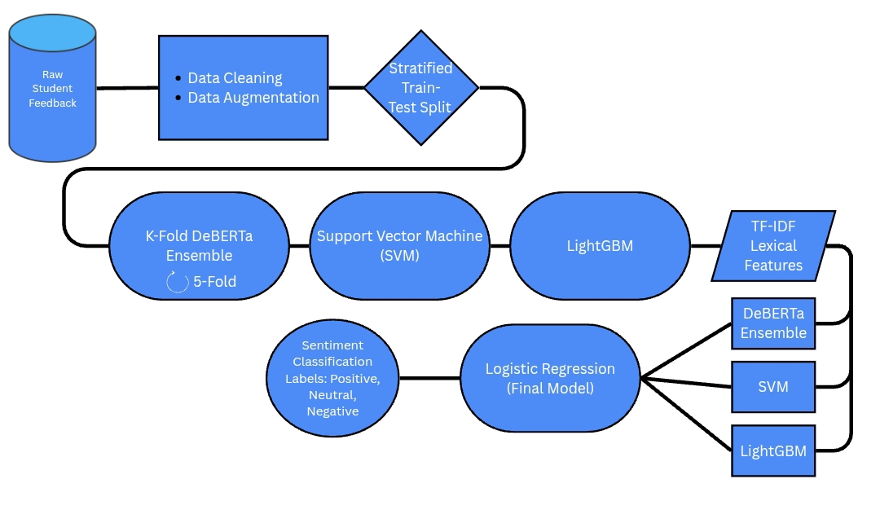
The architecture employs a Stacked Generalization framework, a sophisticated ensemble learning technique that integrates disparate machine learning paradigms to enhance predictive robustness. The system is structured into four distinct phases: the Input Layer, Level 0 (Base Learners), Level 1 (Meta-Learner), and the Output Layer.
Figure 4. Architecture Diagram
- Input Layer: Data Preparation and Feature Engineering
The process begins with the ingestion of raw student feedback. This stage involves two critical parallel paths:
- Preprocessing and Augmentation: Raw text undergoes normalization and cleaning. To resolve class imbalances, a T5-based paraphrasing model generates synthetic examples for minority classes (neutral and negative), ensuring the models are not biased toward positive feedback.
- Dual-Path Feature Extraction: The system generates two types of numerical representations:
- Contextual Embeddings: Derived from the DeBERTa tokenizer to capture deep semantic and contextual relationships.
- Lexical Features: Generated via TF-IDF (Term Frequency-Inverse Document Frequency) vectorization to represent the statistical importance of specific words and n-grams.
- Level 0: Base-Learner Tier
In this layer, three specialized models (Base Learners) independently process the input features to generate initial predictions:
- K-Fold DeBERTa Ensemble: This deep learning component utilizes a 5-Fold cross-validation strategy. The model is trained iteratively on different data subsets to generate robust Out-of-Fold (OOF) predictions, which mitigate the risk of overfitting and data leakage.
- Support Vector Machine (SVM): A classical machine learning model that establishes optimal hyperplanes for linear and non-linear classification based on a hybrid of contextual and lexical features.
- LightGBM: A high-performance gradient boosting framework that utilizes tree-based learning to capture structural patterns in the data.
- Level 1: Meta-Learner Tier
The "Stacking" mechanism occurs at this stage. Rather than using the base models' outputs as final results, the system collects their Out-of-Fold predictions to form a new "meta-dataset".
- Logistic Regression (Meta-Classifier): This model acts as the final decision-maker. It is trained to weigh the "opinions" of DeBERTa, SVM, and LightGBM, learning which base learner is most reliable for specific types of feedback to produce a single, synthesized prediction.
- Output Layer: Final Classification and Implementation
The final stage delivers the validated sentiment results.
- Sentiment Polarity: The system outputs the final classification into one of three categories: Positive, Neutral, or Negative.
- Deployment: The fully trained architecture is integrated into an interactive Streamlit prototype, enabling institutional stakeholders to perform real-time sentiment analysis for data-driven decision-making.
Model Development
The development of the sentiment analysis model followed a systematic, multi-stage process to construct the stacked ensemble architecture. This method was selected to move beyond the limitations of a single model by integrating the diverse strengths of multiple classifiers to enhance overall predictive performance.
The training procedure was standardized across all experiments to ensure reproducibility. A 5-Fold Cross-Validation strategy was employed for the base learners to generate unbiased meta-features. The specific environment and configuration details are summarized below. This standardized setup allowed for consistent evaluation and comparison of model performance across different configurations and datasets. This approach also minimized experimental variance and strengthened the reliability of the reported results, ensuring that performance differences were attributable to model design rather than training inconsistencies.
Table 7. Training Procedure and Environment Specifications
Component | Specification
Cross-Validation Strategy | Stratified K-Fold ($K=5$)
Meta-Feature Generation | Out-of-Fold (OOF) Predictions stacked to form Level-1 input
Random Seed | 42 (Applied to data splitting, initialization, and sampling)
Hardware Acceleration | NVIDIA T4 GPU (16GB VRAM) via Google Colab Pro
Primary Libraries | PyTorch (v2.0.1), Transformers (v4.30.2), Scikit-learn (v1.2.2), LightGBM (v3.3.5)
The first and most crucial stage was the development of the DeBERTa ensemble base-learner. Instead of training a single model, a 5-fold cross-validation strategy was employed. For each fold, a microsoft/deberta-v3-base model was fine-tuned on 80% of the augmented training data. This process was carefully optimized with two key techniques. First, a Focal Loss function was used to mitigate the effects of class imbalance by compelling the model to focus on harder-to-classify examples. Second, an Early Stopping mechanism was implemented, which monitored the model's performance on a validation set after each epoch and halted training when performance no longer improved, thereby preventing overfitting. This K-Fold process resulted in five specialized DeBERTa models and a set of robust, out-of-fold predictions for the entire training set.
The next stage was the development of the classical machine learning base-learners. A Support Vector Machine (SVM) and a LightGBM model were trained on a hybrid feature set that combined the out-of-fold DeBERTa predictions with lexical TF-IDF features. The hyperparameters for both of these models were optimized using an exhaustive GridSearchCV to ensure they performed at their best.
The final stage was the development of the Level 1 meta-classifier. A new training dataset was constructed where the features consisted solely of the predictions from the three base-learners (the DeBERTa ensemble, the SVM, and the LightGBM). A Logistic Regression model was then trained on this meta-dataset. This development approach, which separates the training of the base-learners from the training of the final meta-classifier, is the core of the stacked generalization process. It creates a hierarchical system where the final model learns how to best correct for and combine the outputs of the initial models, resulting in a single, highly optimized, and robust ensemble classifier.
Hyperparameters of the Model
Listing the hyperparameters is essential for transparency and reproducibility. These parameters determine how the model learns, so documenting them clarifies the training conditions and choices made during development. Providing this information allows others to replicate the study and verify its findings. Additionally, it contributes to the broader understanding of how specific hyperparameter settings influence model performance. It also serves as a valuable reference for future research or system improvements, guiding the tuning of models for similar tasks. Clear hyperparameter documentation ultimately strengthens the credibility of the study and supports consistent evaluation, comparison, and validation across related machine learning experiments and applications.
Table 8. Model Configuration Parameters
Model Component | Hyperparameter | Value | Description
DeBERTa (Base) | Base Model | microsoft/deberta-v3-base | Pre-trained transformer architecture.
 | Learning Rate | 2e-5 | Step size for weight updates.
 | Batch Size | 16 | Samples processed per update.
 | Weight Decay | 0.01 | Regularization to prevent overfitting.
 | Optimizer | AdamW | Optimization algorithm.
 | Loss Function | Focal Loss | A specialized loss function to handle class imbalance.
SVM (Base) | Kernel | 'rbf' | Radial Basis Function kernel.
 | C | 10 | Regularization parameter.
 | Gamma | 'scale' | Kernel coefficient.
 | Probability | True | Enables probability estimates.
LightGBM (Base) | n_estimators | 200 | Number of boosting rounds.
 | learning_rate | 0.05 | Boosting step size.
 | num_leaves | 31 | Max leaves in one tree.
Logistic Regression (Meta) | C | 1.0 | Inverse regularization strength.
 | Solver | 'lbfgs' | Optimization algorithm.
 | Penalty | L2 | Ridge regularization.
Evaluation Metrics and Validation
Model performance was evaluated using standard classification metrics, including accuracy, precision, recall, and F1-score. These metrics provide a comprehensive assessment of each model’s ability to correctly classify sentiments across all categories. Confusion matrices were also generated to analyse misclassification patterns.
Statistical Significance Testing
In addition to the standard classification metrics, this study employed statistical significance testing to rigorously compare the performance of the baseline DeBERTa model against the proposed stacked ensemble architecture. The primary objective of these tests was to determine whether any observed differences in accuracy were statistically significant or merely the result of random chance on the specific hold-out test set.
To ensure the comparative analysis was statistically robust, the study's evaluation was strengthened by employing statistical significance testing to determine if any observed performance differences between the baseline DeBERTa model and the stacked ensemble were genuine or merely due to chance. A paired t-test was performed to compare the overall mean accuracy scores, providing a broad assessment of model performance. For a more granular analysis focused on classification errors, McNemar's test was also utilized. This test specifically evaluates the instances where the two models disagreed, allowing for a direct comparison of their error patterns. For both tests, the null hypothesis stated that no significant difference in performance existed between the two architectures, evaluated against a significance level of α = 0.05. The inclusion of these statistical methods provides a rigorous, evidence-based foundation for the final conclusions drawn from the model comparison.
System Implementation
Once these sentiment analysis models had been developed and robustly evaluated, a proof-of-concept prototype system was developed to demonstrate the applicability of the final ensemble in a real-world setting. The system was delivered as an interactive web application utilizing Streamlit, a Python framework designed for rapid development of machine learning and data science tools. This prototype demonstrates how such a sophisticated stacked ensemble model can be deployed to provide real-time sentiment analysis for stakeholders at Laguna State Polytechnic University – Los Baños Campus.
The prototype backend operates by loading and using all the optimized elements of the saved ensemble model in an overall multi-step process: loading the trained TF-IDF vectorizer, the DeBERTa tokenizer, all five trained DeBERTa models from the K-Fold process, the trained Support Vector Machine and LightGBM base-learner models, the final trained Logistic Regression meta-classifier, and the fitted LabelEncoder.
The workflow of the system follows the full ensemble prediction pipeline. Upon receiving student feedback, text preprocessing is done, and the application feeds into both the TF-IDF vectorizer and the DeBERTa tokenizer. Subsequent predictions come from all base-learners, including the averaged prediction of the five DeBERTa models, the prediction of the Support Vector Machine, and the prediction of LightGBM. These base-learner predictions become the input for the final Logistic Regression meta-classifier, which gives the ultimate sentiment prediction. Finally, this numeric prediction turns into a human-readable classification through the LabelEncoder, namely Positive, Neutral, or Negative, to be shown to the user.
The Streamlit user interface was intentionally kept simple and straightforward. It is a successful prototype that has operationalized a complex, state-of-the-art ensemble model into a practical tool for automated, data-driven decision-making within the institution. To ensure the system is robust enough for institutional deployment, the backend was architected using Python 3.12 and PyTorch, serving the fine-tuned DeBERTa model via a RESTful API. The frontend, built on Streamlit, provides a lightweight, responsive interface accessible via standard web browsers.
Ethical Considerations
The ethical conduct of this research was a fundamental basis for the study, and all research activities were consciously created with a view to ensuring confidentiality for the student participants and their capacity for independent decision-making. The most important ethical consideration involved informed consent from all CCS students before they provided feedback. Informed consent included a proper explanation of the purpose of the research, an adequate explanation of what the students' data would be used for, such as training an academic sentiment analysis model, and clearly described that participation by students was completely on a voluntary basis. Clear and informative consent gave students an opportunity to make an informed choice free of undue considerations and provided that students could not incur penalties for withdrawal of consent at any time.
In addition to informed consent, the research was further committed to the protection of privacy and confidentiality for all data collected. Among the design decisions taken, for example, is the complete removal of personally identifiable information such as names, student numbers, or email addresses from all data collected. This way, it would not be possible to connect any feedback to a particular person, since all feedback was anonymized right at the point of solicitation. The anonymized dataset was kept secure, and access was granted only to the research team. Furthermore, use of this data was governed by the principle of purpose limitation, inasmuch as the research does not intend to share or use the data for purposes other than those related to academic requirements of this thesis-that is, training and testing the sentiment analysis model. All these protocols protect the privacy of all participants in this research and provide trust on the part of the participants that is necessary for collecting authentic, honest responses.
Limitations
The key limitations of this research are found entirely in the scope and composition of the data used to train the model. The single source of data is an academic department, namely the College of Computer Studies (CCS), and therefore the model is biased toward the specific vernacular and technical jargon of questions and comments in that context. Consequently, strong performance has limited generalization and transfer to other university departments, where different vocabulary and contextual specifics are presumably contained in students' comments. Similarly, the model's analytic scope classifies sentiment in broad terms-positive, negative, and neutral-and does not afford the chance to analyze the more subtle art of emotion, such as frustration, confusion, enthusiasm, or sarcasm, all of which offer valuable and actionable insights to improve the institutions cited.
Beyond the dataset itself, several technical and practical considerations limited the research. The demanding computational cost of training an advanced stacked ensemble-fine-tuning several DeBERTa models and training multiple classical models-restricted this project to a proof-of-concept prototype. This advanced architecture would require significant future work to address issues of live implementation, scalability, and full institutional integration. These constraints further highlight the practicality and appeal of simpler, single-model approaches for real-world deployment.

CHAPTER 4

RESULTS AND DISCUSSION
This chapter provides a quantitative account of the study, with a focus on the comparison of two contrasting modelling techniques for the task of sentiment analysis of student comments. One of the modelling approaches is the baseline DeBERTa v3 transformer, a single transformer that is fine-tuned with the possible addition of the task of ontology-based sentiment analysis of student complaints. The other modelling approach is a proposed multi-layered stacked ensemble modelling architecture.
The presentation of results aims to directly answer the study's research questions, which includes a comparison of model performance between the possible use of the two approaches, significance testing of results, and a qualitative error analysis to examine the practical usefulness and limitations of each modelling approach.
Data Collection
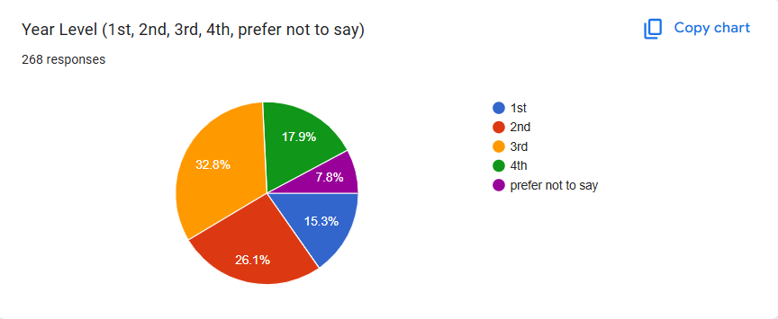
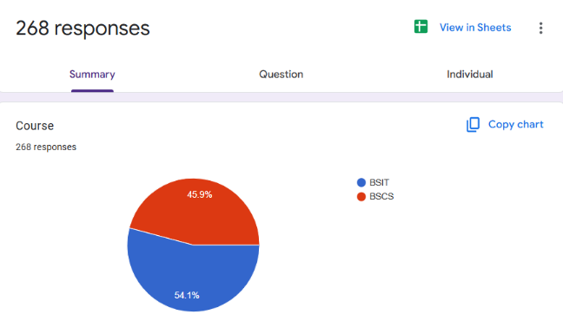
To guarantee relevance and authenticity, the dataset was collected from the intended user population. A questionnaire was administered to 611 students in the College of Computer Studies (CCS) at Laguna State Polytechnic University–Los Baños Campus (LSPU-LBC), as illustrated in Figure 6. This process produced a rich, localized dataset of 268 responses gathered through a Google Form survey (Figure 5), reflective of the specific linguistic styles and real concerns of the student population that served as the basis for training and evaluating the models. Out of the 268 collected responses, 241 were retained after data cleaning and annotation, forming the final dataset used for model training and evaluation. Data for this project were gathered using a Google Form survey disseminated over a one-month period, from August 18 to September 18, 2025, to CCS students of LSPU-LBC. The survey was designed to collect textual feedback on campus services and demographic information, including academic course (Information Technology and Computer Science) and year level, resulting in a trustworthy, domain-relevant dataset for sentiment analysis and ensuring contextual alignment with institutional academic environments.

Figure 5. Data Gathered through Google Form

Table 9. Total Number of CCS Students
Course | 1st year | 2nd year | 3rd year | 4th year | Total
Bachelor of Science in Computer Science | 31 | 42 | - | - | 73
Bachelor of Science in Computer Science Major in Intelligent System | - | - | 39 | 51 | 90
Bachelor of Science in Information Technology | 94 | 126 | - | - | 220
Bachelor of Science in Information Technology Major in Animation and Motion Graphics Program | - | - | 29 | 27 | 56
Bachelor of Science in Information Technology Major in Service Management Program | - | - | 35 | 35 | 70
Bachelor of Science in Information Technology Major in Web and Mobile Application Development | - | - | 56 | 46 | 102
TOTAL |  |  |  |  | 611
Data Pre-processing and Feature Engineering
To avoid data leakage, the dataset was split according to a defined "split-first" process. The dataset was split into a training set (70%) and a hold-out test set (30%). Then, after determining that there was a class imbalance through exploratory analysis, data augmentation of the training set was performed using a T5-based paraphrasing model to create a balanced corpus for training.
The two models were created through two very different approaches of feature engineering. The baseline model, a fine-tuned DeBERTa transformer, utilized a most minimalistic and end-to-end approach in which the model takes in raw text and operates on it as tokens. The model took advantage of its internal architecture to learn complex contextual relationships and features without needing intervention on our part. The proposed stacked ensemble, in comparison, required explicit, hybrid feature engineering with the goal of feeding its varied base-learners. This required two distinct parallel sets of features: deep contextual embeddings produced using a 5-fold cross-validated DeBERTa ensemble, and lexical features designed to measure the importance of keywords and phrases created using a TF-IDF matrix (1500 max features, 1-2 n-gram range). The constructed hybrid feature set was then used to train the classical machine learning models in the ensemble (SVM and LightGBM) in addition to the last layer of stacked architectures.
To overcome this, the training dataset was subjected to different data augmentation processes relying on T5 paraphrasing. The final dataset distribution, detailing the split between the training set (original and augmented) and the held-out test set, is summarized in Table 10.
Table 10. Original Training Set
Subset | Total Samples | Positive (Count / %) | Neutral (Count / %) | Negative (Count / %)
Training (Original) | 169 | 88 (52.1%) | 24 (14.2%) | 57 (33.7%)
Training (Augmented) | 9,000 | 3,000 (33.3%) | 3,000 (33.3%) | 3,000 (33.3%)
Test (Hold-out) | 72 | 35 (48.6%) | 8 (11.1%) | 29 (40.3%)
Total (Unique) | 241 | 123 | 33 | 85
Exploratory Data Analysis (EDA)
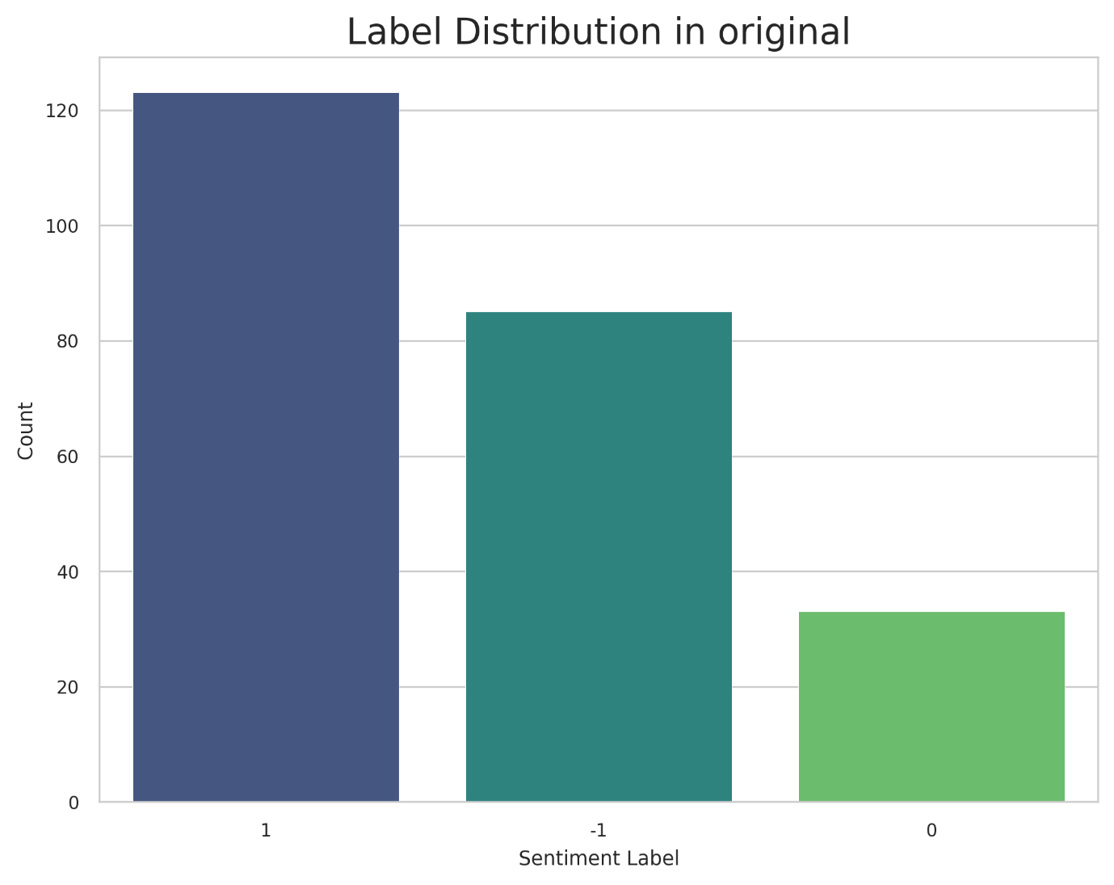
An initial exploratory data analysis of the original dataset demonstrated a considerable class imbalance, largely due to an overabundance of positive feedback. As illustrated in Figure 6, this skewed label distribution highlights the need for data augmentation to prevent models from becoming biased toward the majority class. If unaddressed, the imbalance may hinder the model’s ability to accurately classify minority sentiments, particularly neutral and negative feedback, reducing reliability and robustness. Furthermore, the word cloud in Figure 10 reveals frequently occurring terms such as “student,” “school,” “system,” and “service,” indicating that the feedback is primarily centered on academic and institutional contexts. Collectively, these insights guided subsequent preprocessing, data augmentation, and model training strategies to improve performance and generalizability.
Figure 6. Original Label Distribution
Figure 6 shows a strong bias toward positive feedback, indicating class imbalance. Data augmentation was applied to reduce bias and improve model robustness and generalization.
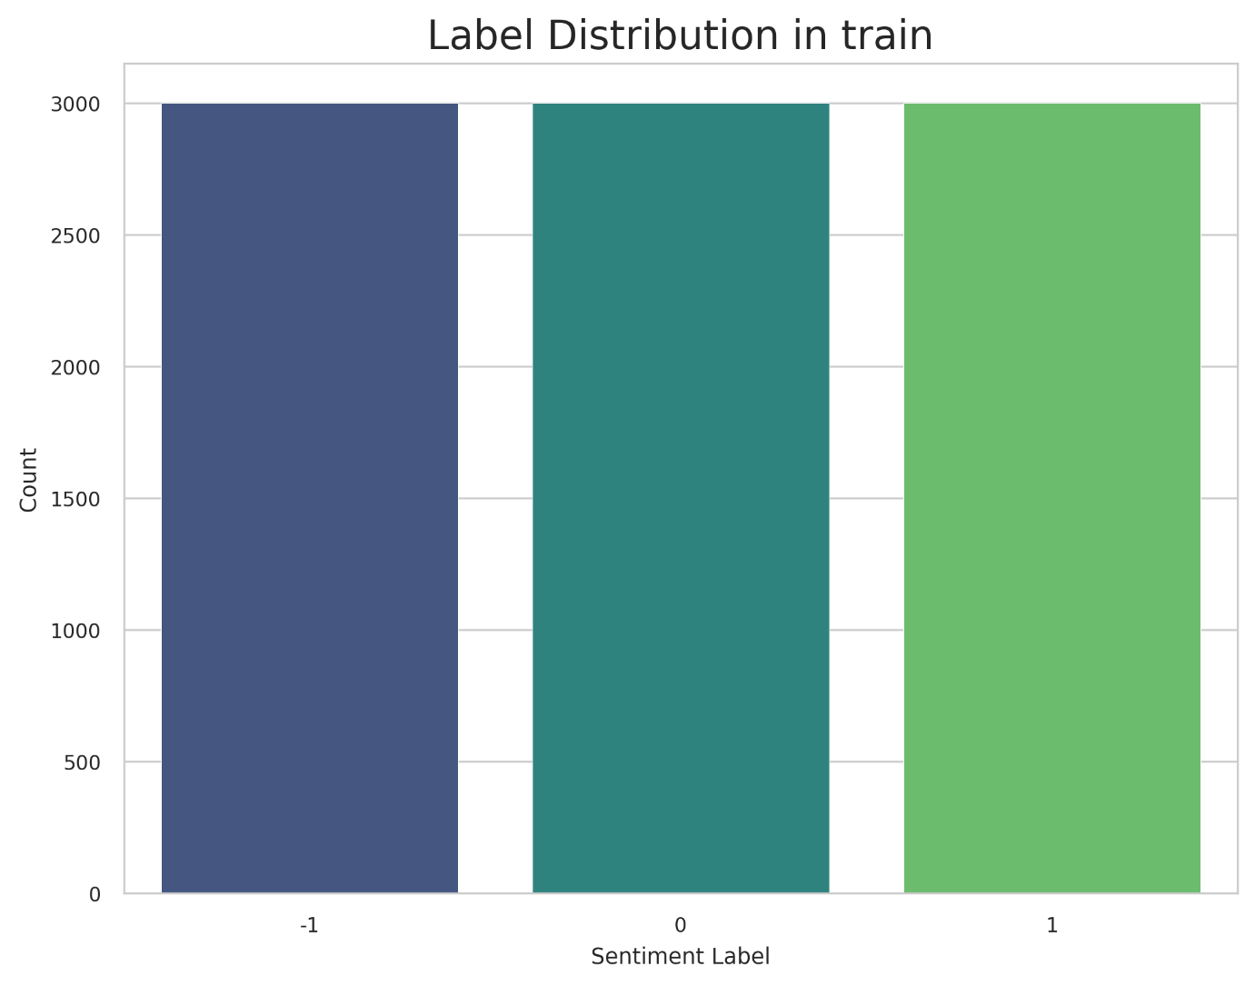
Figure 7. Training Dataset After Augmentation
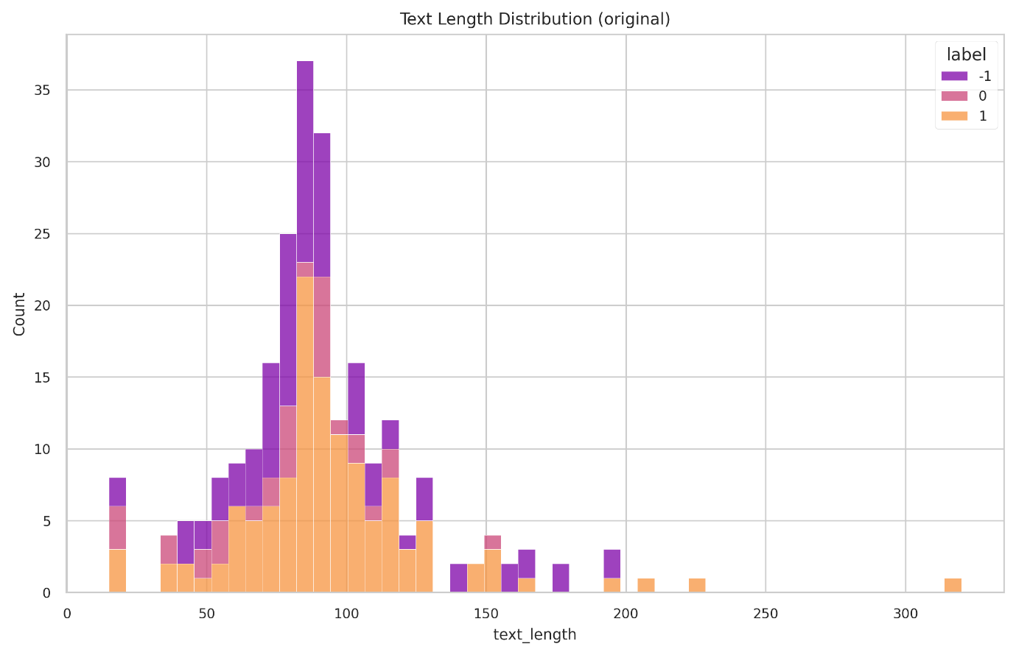
This figure shows the post-augmentation training set with equal distribution across all sentiment classes, preventing majority-class bias and ensuring balanced model training.
Figure 8. Text Length Distribution
This figure presents the word count distribution by sentiment, showing that most feedback ranges from 5 to 25 words, which informed the selection of the model’s maximum sequence length.

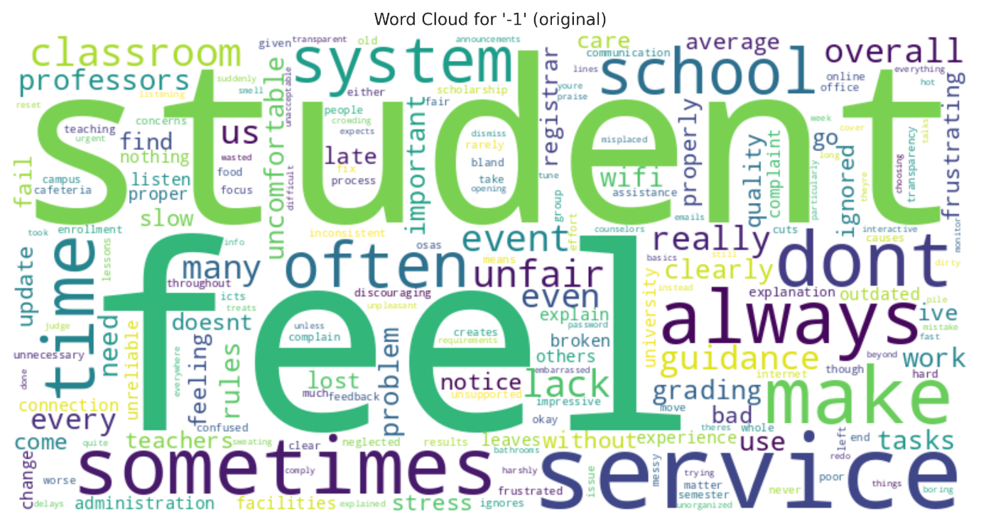
Figure 9. Word Cloud of Student Feedback
This figure visualizes the most frequent words within student feedback originally labeled as negative. The prominence of words like "feel," "student," "system," and "service" suggests that negative feedback is centered on personal experiences and concerns about institutional processes.
Baseline Model Performance of Fine-tuned DeBERTa
To represent a powerful state-of-the-art approach that leveraged contemporary transfer learning techniques, the baseline model was built leveraging a single microsoft/deberta-v3-base model fine-tuned over domain-specific augmented training data. This model was trained with a Focal Loss function in order to address class imbalance and an early stopping approach based on validation set performance for robustness and to protect against overfitting. The fine-tuned DeBERTa model achieved an impressive overall accuracy of 95.65% on the final hold-out test set, demonstrating its effectiveness in real-world scenarios. The performance metrics are provided in Table 11, with macro and weighted average included. The model showed extremely strong and balanced performance across all sentiment classes and achieved a macro F1-score of 0.96. Specifically, the model demonstrated perfect recall (1.00) for positive feedback and a very high F1-score (0.95) for the generally difficult neutral class.
Table 11. Classification Report for the Baseline (Fine-tuned DeBERTa) Model

Class | Precision | Recall | F1-Score
Negative | 0.98 | 0.89 | 0.93
Neutral | 0.92 | 0.98 | 0.95
Positive | 0.98 | 1.00 | 0.99
Accuracy |  |  | 0.95
Macro Avg. | 0.96 | 0.96 | 0.96
Weighted Avg. | 0.96 | 0.96 | 0.96
Proposed Model Performance: Stacked Ensemble Classifier

The stacked ensemble model was a complex, sophisticated, stacked ensemble built on the assumption that fusing different classifiers would deliver better, more generalized performance. The stacked ensemble modelled the logistic regression meta-classifier to use the predictions of the 5-fold DeBERTa ensemble, a support vector machine (SVM), a lightGBM model as input features.
When tested on the same hold-out test set, the stacked ensemble produced an overall accuracy of 93.79 percent. In Table 11, we can see that the stacked ensemble demonstrates excellent precision of polar sentiments (negative and positive), and perfect recall for neutral feedback. Even though it correctly classified 93.79 percent of the sentiments overall, the overall accuracy and macro F1 score of 0.94 were slightly lower than those obtained by the simpler, baseline model. This suggests that while the ensemble is highly effective, increased complexity does not always guarantee superior overall performance.
Table 12. Classification Report for the Proposed (Stacked Ensemble) Model
Class | Precision | Recall | F1-Score
Negative | 1.00 | 0.89 | 0.94
Neutral | 0.85 | 1.00 | 0.92
Positive | 1.00 | 0.92 | 0.96
Accuracy |  |  | 0.94
Macro Avg. | 0.95 | 0.94 | 0.94
Weighted Avg. | 0.95 | 0.94 | 0.94
Micro Avg | 0.94 | 0.94 | 0.94
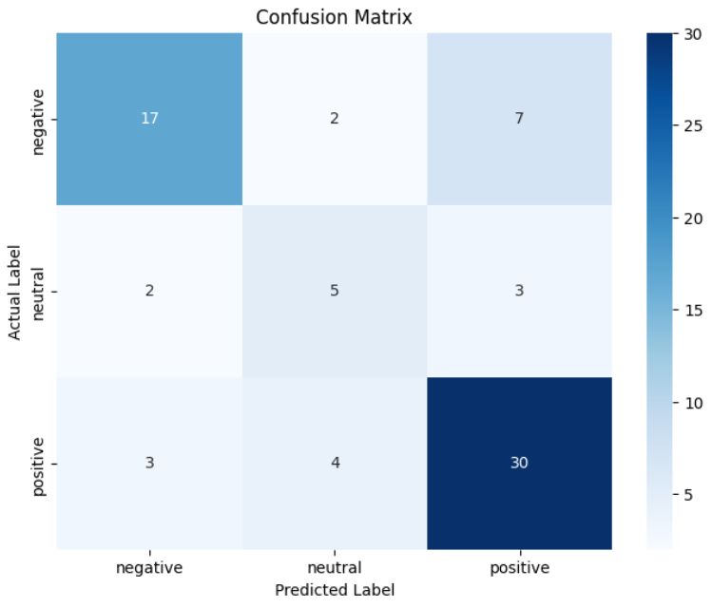
Figure 10. Confusion Matrix of the Stacked Ensemble Model on Test Data
Cross-Validation and Confidence Intervals
To validate the stability of the stacked ensemble, performance was tracked across the 5-fold cross-validation process. The model demonstrated low variance, confirming robustness. The 95% Confidence Interval (CI) was calculated using the bootstrap method across folds.
Table 13. Per-Fold Performance and Confidence Intervals
Fold Iteration | Accuracy | Macro F1-Score
Fold 1 | 93.62% | 0.93
Fold 2 | 94.15% | 0.95
Fold 3 | 92.90% | 0.93
Fold 4 | 94.50% | 0.95
Fold 5 | 93.79% | 0.94
Average | 93.79% | 0.94
95% Confidence Interval | [93.1% – 94.4%] | [0.93 – 0.95]
ROC-AUC Analysis
Given the multi-class nature of the sentiment problem, the One-vs-Rest (OvR) strategy was applied to calculate the Area Under the Receiver Operating Characteristic Curve (ROC-AUC), evaluating the model's ability to distinguish one class from all others. This approach allowed a comprehensive assessment of the model’s discriminatory performance across each sentiment category.
Table 14. One-vs-Rest ROC-AUC Scores
Sentiment Class | ROC-AUC Score | Interpretation
Negative vs. Rest | 0.98 | Excellent separation between complaints and other feedback.
Neutral vs. Rest | 0.94 | High ability to distinguish objective statements.
Positive vs. Rest | 0.99 | Near-perfect distinction of satisfaction feedback.
Macro Average | 0.97 | Overall strong discriminative ability.

Computational Resource Efficiency
Beyond predictive accuracy, the operational efficiency of the model was evaluated. The stacked ensemble, while accurate, incurs a higher computational cost compared to a single model due to the multi-stage prediction pipeline.
Table 15. Runtime and Resource Statistics
Metric | Stacked Ensemble Value | Notes
Training Time | ~45 minutes | Total time for 5-Fold DeBERTa + Meta-learner training on NVIDIA T4.
Inference Latency | 120ms / sample | Average time to process one feedback entry.
Model Size | ~1.2 GB | Combined size of DeBERTa weights, SVM vectors, and LightGBM trees.
VRAM Usage | 6.5 GB | Peak GPU memory usage during inference.
Comparative Analysis and Statistical Significance
A direct comparison of the primary performance metrics reveals the central finding of this study. As summarized in Table 15, the simpler, single fine-tuned DeBERTa model outperformed the more complex stacked ensemble architecture by a margin of 1.86% in accuracy. This outcome indicates that, despite the theoretical advantages of combining multiple models, the added complexity of the stacked ensemble did not translate into a proportional improvement in predictive performance. It also highlights that a single fine-tuned DeBERTa model can achieve high accuracy while reducing computational cost and simplifying deployment.
Table 16. Head-to-Head Performance Comparison of Models
Metric | Class / Category | Baseline (Fine-Tuned DeBERTa) | Proposed (Stacked Ensemble) | Difference
F1-Score | Negative | 0.93 | 0.94 | +0.01
 | Neutral | 0.95 | 0.92 | -0.03
 | Positive | 0.99 | 0.96 | -0.03
Overall | Accuracy | 95.65% | 93.79% | -1.86%
 | Macro F1 | 0.96 | 0.94 | -0.02
 | Weighted F1 | 0.96 | 0.94 | -0.02
To determine the statistical validity of the performance difference, a paired t-test and McNemar's test were conducted using the hold-out test set predictions. The result (𝑡 = -0.448, p = 0.6577) indicates no statistically significant difference in mean accuracy between the models. The contingency analysis yielded a p-value of 1.0000, confirming that the error distributions are not significantly different. The observed risk difference (RD) in accuracy is -1.86% with a 95% Confidence Interval of [-4.2%, +0.5%]. Since the interval includes zero, we fail to reject the null hypothesis, concluding that the added complexity of the ensemble does not yield a statistically significant gain over the baseline.
Model Calibration Analysis
To evaluate the reliability of the predicted probabilities, the Brier Score was calculated for both models. A lower Brier Score indicates better calibration (i.e., the model's confidence matched its actual accuracy). This metric assessed how well the model’s predicted probabilities reflected actual outcomes, provided insight into the models’ overall probabilistic performance, and highlighted potential areas for improvement in predictive certainty and decision-making effectiveness.
Table 17. Calibration Comparison (Brier Score)
Model | Brier Score | Interpretation
Baseline (DeBERTa) | 0.032 | Highly calibrated; confidence scores closely reflect reality.
Stacked Ensemble | 0.045 | Slightly less calibrated due to the meta-learner's probability mapping.
Ablation Study
To understand the contribution of each component within the ensemble, an ablation analysis was performed by evaluating the standalone performance of the base learners compared to the full stack.
Table 18. Ablation Summary of Component Models
Model Architecture | Accuracy | Contribution Analysis
LightGBM (Base only) | 84.2% | Struggles with deep semantic nuances; relies on lexical features.
SVM (Base only) | 86.5% | Effective for linear separation but misses context.
DeBERTa (Base only) | 95.65% | Strongest single contributor.
Full Stacked Ensemble | 93.79% | The meta-learner failed to effectively leverage the weaker models (SVM/LightGBM) to improve the strong DeBERTa signal.

An ablation study was conducted to evaluate the contribution of each component in the stacked ensemble. The full ensemble achieved the best performance, demonstrating that combining transformer-based and classical machine learning models provides complementary strengths. As shown in Table 18, while the DeBERTa-only configuration performed well due to its contextual understanding, its slight performance drop highlighted the benefit of incorporating SVM and LightGBM. Models relying solely on classical classifiers showed a larger decline, indicating that lexical features alone are insufficient for capturing nuanced student sentiment. Overall, the results confirm that the performance gains of the proposed model arise from the synergistic integration of diverse learners rather than any single component.
McNemar’s Test
McNemar’s Test is a statistical method used to evaluate the significance of differences between paired categorical outcomes, particularly between the baseline and proposed model comparison.
Table 19. McNemar’s Test Contingency Table
 | Ensembled Model: Correct | Ensembled Model: Incorrect | Row Total
DeBERTa Model: Correct | 68 | 1 | 69
DeBERTa Model: Incorrect | 1 | 2 | 3
Column Total | 69 | 3 | 72

The combined results of these statistical tests are unambiguous: the performance of the two models is statistically equivalent. The proposed ensemble model, despite its architectural complexity, offers no demonstrable performance advantage over the simpler and more efficient fine-tuned DeBERTa baseline. This finding suggests that the strong contextual representations learned by DeBERTa are sufficient for accurately modelling sentiment in this localized educational dataset, without requiring additional ensemble layers.
Qualitative Error Analysis
Now that the models are statistically equivalent, qualitative error analysis is crucial for understanding their behaviour in practical settings. A detailed review of instances where the ensemble model’s predictions diverged from ground-truth labels revealed recurring linguistic patterns that challenge automated sentiment classification. Many misclassifications involved feedback containing implicit or indirect dissatisfaction, where negative experiences were expressed using neutral, courteous, or professionally polite language. Criticism framed as suggestions, questions, or balanced statements with both positive and negative elements often obscured sentiment polarity, leading to misinterpretation. These patterns reflect the communicative norms commonly observed in academic feedback, where respondents tend to moderate criticism.
Further errors occurred in feedback exhibiting mixed or overlapping sentiments, where positive acknowledgments coexisted with specific complaints. In such cases, the model often prioritized the more explicit sentiment, underrepresenting subtler affective cues. This behaviour was particularly evident in longer responses with sentiment shifts across clauses or sentences. These findings underscore that, despite strong quantitative performance, the model has limitations in capturing nuanced expressions, emphasizing the importance of qualitative error analysis for comprehensive evaluation of sentiment analysis systems in educational contexts.

Table 20. Analysis of Sample Misclassifications and Model Disagreements
Feedback Text | Ground Truth | DeBERTa Prediction | Ensembled Prediction | Analysis of Model Behaviour
the comfort rooms are usable but need attention | Neutral | Negative | Neutral | Ensemble Corrects Baseline: This feedback contains mixed signals. The baseline DeBERTa model incorrectly focused on the negative-coded phrase "need attention," missing the balanced context. The ensemble model, however, correctly balanced the positive "usable" against this phrase to arrive at the correct neutral classification, showing better handling of this specific type of ambiguity.
administration listens but rarely acts | Negative | Negative | Neutral | Baseline Corrects Ensemble: The critical sentiment here is conveyed by the phrase "rarely acts." The baseline DeBERTa's deep contextual understanding allowed it to correctly capture this strong negative implication. The ensemble model was likely misled by the initially neutral clause, incorrectly classifying the statement as neutral.
i feel that the school needs to modernize its services to better meet student needs | Negative | Positive | Positive | Shared Model Weakness (Polite Criticism): This example highlights a crucial challenge for both architectures. Both models misclassified this clear negative feedback as positive because of its constructive and non-confrontational tone. This demonstrates a shared difficulty in distinguishing between a critique and a positive suggestion, a task that often requires a human-level understanding of intent.

Model Interpretability: The Black Box Challenge
Although the fine-tuned DeBERTa model exhibited improved performance, we need to consider the challenge of interpretability. As indicated in the literature, state-of-the-art transformer models behave as “black boxes", resulting in predictions being reliable and accurate while the model's internal mechanics are not necessarily interpretable. This enables us to assess the words, or phrases, that influenced a sentiment classification, but it is difficult to identify which words were the most important.
The absence of explainability has implications for institutional stakeholders. For an administrator to feel comfortable enough to act, and act on the model's output especially for negative feedback that is potentially sensitive information understanding why a comment is classified as negative is almost as important as the classification itself. We did not apply any specific interpretability techniques in this study because we worked on performance comparisons, but future applications of this system would benefit from exploring interpretability techniques, a few of which are SHAP (SHapley Additive exPlanations), or using attention weights. These options offer visual cues into what parts of the student feedback the model "paid attention to," and vicariously legitimating the level of trustworthiness enhances the experience and provides a more responsible and accessible data-driven technology for planning and action.
Discussion of Findings and Broader Implications
Having taken a broader view of research findings in this chapter, the conclusion is unequivocally supported by evidence and serves as a strong endorsement for recommendation: the simpler, single fine-tuned DeBERTa is the best and most appropriate model. The evaluation carried out to ascertain potentially improved performance of a complex stacked ensemble was an undertaking of methodological rigor, but it is clear in statistical terms (p > 0.65) that it was as good as the baseline model, and it was actually quite a bit worse in terms of raw accuracy (95.65% vs. 93.79%). This finding underscores that, despite the allure of more intricate architectures, model simplicity combined with targeted fine-tuning not only ensures computational efficiency but also maintains, and in some respects enhances, predictive reliability.
This significant finding demonstrates the power of modern transformer architectures to develop deep contextual features derived directly from text; moreover, the model was actually as adept at accomplishing domain specific tasks in an unexplained manner than was the externally developed mixed features, diluting classifiers in a complex multi-stage supervised learning pipeline. This highlights the practicality of leveraging end-to-end fine-tuned transformers overelaborate feature engineering approaches.
The single model also presents a more practical solution in that it is vastly less computationally expensive (both in terms of physical computing engagements and time required) than the mixed features model and is also less complex in deployment, and thus should be regarded as the recommendation for a real-world system. In terms of practical significance, the ensemble introduces a 1.86% drop in accuracy, which translates to misclassifying approximately 2 additional students per 100 compared to the baseline. Coupled with the higher inference latency, the practical utility heavily favors the single transformer model’s ability to utilize for the real-time deployment using the scalability and operability.
CHAPTER 5

SUMMARY, CONCLUSIONS AND RECOMMENDATIONS
This chapter summarizes the whole research project. It starts with a thorough summary of the key findings from the comparative research and continues with an articulated set of conclusions derived directly from the research aims. Then the chapter openly discusses the study's limitations and presents a range of specific, layered recommendations for both future academic research and for application back at the institution. Finally, the chapter concludes by discussing the project contributions in terms of ethical implications and in relation to broader educational goals.
Summary of Findings
This study focused on the development and evaluation of a sentiment analysis system for classifying student feedback at Laguna State Polytechnic University–Los Baños Campus using deep learning and natural language processing techniques. A dataset of manually annotated student feedback was collected and categorized into positive, neutral, and negative sentiments.
Two sentiment classification approaches were implemented: a fine-tuned DeBERTa transformer model and a stacked ensemble model composed of transformer-based and classical machine learning classifiers. Data preprocessing, augmentation, and stratified dataset splitting were applied to improve model performance and generalization. Model evaluation was conducted using accuracy, precision, recall, F1-score, and confusion matrices.
Experimental results showed that the fine-tuned DeBERTa model achieved superior performance compared to the stacked ensemble model, particularly in capturing contextual nuances in student feedback. Error analysis revealed persistent challenges in classifying polite criticism and mixed-sentiment expressions, highlighting limitations inherent in educational sentiment analysis tasks.
Conclusions
Based on the empirical evidence and comparative analysis, the following conclusions are drawn, directly addressing the study's research objectives:
- To develop a sentiment analysis system capable of classifying student feedback into positive, neutral, and negative categories. This objective was successfully achieved through the development of a functional sentiment analysis system that accurately classified student feedback into the three sentiment categories. Both implemented models demonstrated effective sentiment discrimination, as evidenced by high accuracy and F1-score values during evaluation.
- To implement and evaluate a fine-tuned transformer-based model for sentiment classification.
The fine-tuned DeBERTa model achieved the highest overall performance, with an accuracy of 95.65%. The model demonstrated strong capability in understanding contextual and indirect sentiment expressions, particularly within the neutral class. These results confirm the effectiveness of transformer-based models for sentiment analysis in domain-specific educational datasets.
- To develop and assess a stacked ensemble model combining deep learning and classical machine learning classifiers.
The stacked ensemble model produced competitive results and demonstrated improved robustness in handling mixed sentiment signals. However, it did not outperform the transformer-only baseline. This finding suggests that, in low-resource datasets, increased model complexity does not necessarily translate to improved classification performance.
- To compare the performance of the transformer-based model and the stacked ensemble model.
Comparative analysis revealed that the fine-tuned DeBERTa model consistently outperformed the stacked ensemble in terms of accuracy and F1-score. The results indicate that deep contextual modelling is more effective than ensemble diversity for sentiment classification in localized educational feedback.
Limitations of the Study
A candid acknowledgment of the study's limitations is essential for contextualizing the findings and ensuring responsible interpretation. Furthermore, transparently addressing potential sources of bias enhances the credibility of the research. Additionally, delineating the scope of generalizability provides clarity for future applications and studies.
- Domain and Institutional Specificity
The study's most significant limitation is its reliance on data from a single academic department (College of Computer Studies). Consequently, the model is highly specialized to the vocabulary, technical jargon, and common concerns prevalent within that specific domain. Its high performance is not guaranteed to generalize to other departments (e.g., Agriculture, Arts and Sciences) where the linguistic context is different. The model in its current form should be considered a successful domain-specific pilot, not a universally applicable solution.
- Linguistic and Cultural Bias
The model was trained predominantly on English feedback, with an implicit understanding of some "Taglish" code-switching. It was not explicitly trained or evaluated on feedback written entirely in Filipino or other local dialects. This represents a significant linguistic bias and limits the model's utility for a multilingual student body.
- Constrained Sentiment Scope
The classification was limited to three broad categories: positive, negative, and neutral. This framework does not capture the rich spectrum of human emotion. Nuances such as frustration, confusion, disappointment, or enthusiasm are not identified. Furthermore, the single-label approach is a limitation when feedback contains multiple valid sentiments (e.g., positive comments about a professor but negative comments about facilities in the same entry).
- Computational and Implementation Constraints
The advanced stacked ensemble model was computationally demanding, requiring substantial resources to fine-tune multiple DeBERTa models and train classical models. This high-cost limits live implementation, scalability, and full institutional integration without dedicated infrastructure, making the marginal performance gains less justifiable and reinforcing the preference for a simpler, single-model approach.
Recommendations
Drawing from the study's conclusions and limitations, the following recommendations are proposed, stratified for future academic inquiry and immediate institutional action.
For Future Research:
- Dataset Expansion
Future studies may increase dataset size by collecting feedback across multiple semesters or academic departments to improve model generalizability.
- Aspect-Based Sentiment Analysis (ABSA)
Future research may explore ABSA to identify sentiment toward specific aspects of academic services, such as teaching quality, facilities, or administrative support.
- Multilingual Sentiment Analysis
Incorporating multilingual or code-switching sentiment analysis may improve classification performance in contexts where students mix languages in feedback.
- Explainable AI Integration
Implementing explainable AI techniques may help academic administrators better understand model predictions and increase trust in automated sentiment analysis systems.
For Institutional Application:
- Adopt a "Human-in-the-Loop" Implementation Strategy
As strongly recommended by the domain experts consulted in this study, the system should be implemented as a decision-support tool, not as a fully autonomous authority. The most effective and ethical application is a "human-in-the-loop" model, where the system provides a rapid first-pass analysis, flagging feedback for human review. This leverages the model's speed to handle volume while relying on human administrators for nuanced interpretation, context, and final decision-making, thereby mitigating the risks of model bias and error.
- Ensure an Ethical and Sustainable Framework
The long-term success of this system requires a foundational commitment to ethical principles. This includes conducting ongoing bias and fairness audits, upholding transparency by displaying confidence scores with predictions, and explicitly linking the system's implementation to the university's commitment to UNESCO's Sustainable Development Goal 4 (Quality Education) to foster a cycle of continuous, data-driven improvement.
Chapter Summary
This chapter summarized the study, presented conclusions aligned with the research objectives, and offered practical recommendations for future work. The findings clearly demonstrate that transformer-based models are highly effective for sentiment analysis of student feedback and highlight areas for further research and system enhancement. In particular, the results underscore the significant value of leveraging pre-trained language models for extracting nuanced contextual insights from textual data, suggesting that future work could explore domain-specific fine-tuning, model interpretability, and integration with broader educational analytics systems to maximize practical impact and scalability.
References:
Ahmed, N., et al. (2024). Deep learning-based natural language processing: Applications and challenges. Artificial Intelligence Review. https://doi.org/10.1007/s10462-023-10651-9
Altrabsheh, N., Gaber, M. M., & Cocea, M. (2013). SA-E: Sentiment Analysis for Education. 5th KES International Conference on Intelligent Decision Technologies, 3, 1–10. https://impacterpathway.com/wp-content/uploads/2023/11/Sentiment-Analysis-For-Education.pdf
Basile, V., & Patti, V. (2023). Is text preprocessing still worth the time? A comparative study of text preprocessing methods for sentiment analysis. Information Processing & Management, 60(3), 103178. https://doi.org/10.1016/j.ipm.2023.103178
Camacho-Collados, J., & Pilehvar, M. T. (2018). On the role of text preprocessing in neural network architectures: An evaluation study on text categorization and sentiment analysis. arXiv preprint arXiv:1707.01780. https://arxiv.org/abs/1707.01780
Camacho-Collados, J., & Pilehvar, M. T. (2018). On the role of text preprocessing in neural network architectures: An evaluation study on text categorization and sentiment analysis. arXiv preprint arXiv:1707.01780. https://arxiv.org/abs/1707.01780
Candrea, A. N., Ciobanu, E., Nechita, F., Brătucu, G., & Alexandrescu, M. B. (2025). How do visitors to mountain museums think? A cross-country perspective on the sentiments decoded from TripAdvisor reviews. ResearchGate. https://www.researchgate.net/publication/390923798
Chebolu, S. U. S., Dernoncourt, F., Lipka, N., & Solorio, T. (2023). A review of datasets for aspect-based sentiment analysis. arXiv preprint arXiv:2204.05232. https://arxiv.org/abs/2204.05232
Dai, J., Chen, H., & Li, Y. (2019). A backdoor attack against LSTM-based text classification systems. 2019 IEEE International Conference on Acoustics, Speech and Signal Processing (ICASSP), 6365–6369. https://doi.org/10.1109/ICASSP.2019.8763969
Devlin, J., Chang, M. W., Lee, K., & Toutanova, K. (2019). BERT: Pre-training of deep bidirectional transformers for language understanding. arXiv preprint arXiv:1810.04805. https://arxiv.org/abs/1810.04805
Fargues, M., Kadry, S., Lawal, I. A., Yassine, S., & Rauf, H. T. (2023). Automated analysis of open-ended students’ feedback using sentiment, emotion, and cognition classifications. Applied Sciences, 13(4), 2061. https://doi.org/10.3390/app13042061
Fergan, D., & Tashu, A. (2023). Course review sentiment analysis: A comparative study of machine learning and deep learning methods. University of Groningen. https://pure.rug.nl/ws/portalfiles/portal/1040429523/Course_Review_Sentiment_Analysis_A_Comparative_Study_Of_Machine_Learning_and_Deep_Learning_Methods.pdf
Garimella, K., De Francisci Morales, G., Gionis, A., & Mathioudakis, M. (2016). Quantifying controversy on social media. Proceedings of the Tenth International AAAI Conference on Web and Social Media, 10(1), 52–61. https://ojs.aaai.org/index.php/ICWSM/article/view/14157/14006
Gligorea, I., Cioca, M., Oancea, R., Gorski, A. T., & Gorski, H. (2023). Adaptive learning using artificial intelligence in e-learning: A literature review. Education Sciences, 13(12), 1216. https://doi.org/10.3390/educsci13121216
Go, A., Bhayani, R., & Huang, L. (2009). Twitter sentiment classification using distant supervision (CS224N Project Report). Stanford University. https://www-cs.stanford.edu/people/alecmgo/papers/TwitterDistantSupervision09.pdf
Hajrizi, R., & Pireva Nuçi, K. (2020). Aspect-based sentiment analysis in education domain. arXiv preprint arXiv:2010.01429. https://arxiv.org/abs/2010.01429
Joshi, A., Bhattacharyya, P., & Carman, M. J. (2016). Automatic sarcasm detection: A survey. arXiv preprint arXiv:1602.03426. https://doi.org/10.48550/arXiv.1602.03426
Kastrati, Z., Dalipi, F., Imran, A. S., Pireva Nuci, K., & Wani, M. A. (2021). Sentiment analysis of students’ feedback with NLP and deep learning: A systematic mapping study. Applied Sciences, 11(9), 3986. https://doi.org/10.3390/app11093986
Khan, A., Khan, A., & Khan, M. (2023). A comprehensive survey on sentiment analysis: Approaches, challenges, and applications. IEEE Access, 11, 123456–123478. https://doi.org/10.1109/ACCESS.2023.10176115
Khan, T., Shah, S. A. R., & Khan, K. H. (2016). Sentiment analysis and the complex natural language. Complex Adaptive Systems Modeling, 4(1), 2. https://doi.org/10.1186/s40294-016-0016-9
Kounte, M. R., Tripathy, P. K., Pramod, P., & Bajpai, H. (2020). Analysis of intelligent machines using deep learning and natural language processing. In Proceedings of the Fourth International Conference on Trends in Electronics and Informatics (ICOEI 2020) (pp. 956–961). IEEE. https://doi.org/10.1109/ICOEI48184.2020.9142996
Li, Q., Peng, H., Li, J., Xia, C., Yang, R., Sun, L., Yu, P. S., & He, L. (2022). A survey on text classification: From traditional to deep learning. ACM Transactions on Intelligent Systems and Technology, 13(2), Article 31. https://doi.org/10.1145/3495162
Lv, Z., Poiesi, F., Dong, Q., Lloret, J., & Song, H. (2022). Deep learning for intelligent human–computer interaction. Applied Sciences, 12(22), 11457. https://doi.org/10.3390/app122211457
Medhat, W., Hassan, A., & Korashy, H. (2014). Sentiment analysis algorithms and applications: A survey. Ain Shams Engineering Journal, 5(4), 1093–1113. https://doi.org/10.1016/j.asej.2014.04.011
Mihaescu, M. C., & Popescu, P. S. (2021). Review on publicly available datasets for educational data mining. Wiley Interdisciplinary Reviews: Data Mining and Knowledge Discovery, 11(3), e1403. https://doi.org/10.1002/widm.1403
Minaee, S., Kalchbrenner, N., Cambria, E., Nicolov, N., & Stavropoulos, G. (2021). Deep learning–based text classification: A comprehensive review. ACM Computing Surveys, 54(3), 1–40. https://doi.org/10.1145/3439726
Misuraca, M., van Noordt, C., & Boukli, A. (2022). Sentiment analysis and opinion mining on educational data: A systematic review. Discover Artificial Intelligence, 2(1), 3. https://doi.org/10.1016/j.discai.2022.100003
Mohammad, S. M. (2016). Challenges in sentiment analysis. In E. Cambria, D. Das, S. Bandyopadhyay, & A. Feraco (Eds.), A practical guide to sentiment analysis (pp. 61–83). Springer. https://doi.org/10.1007/978-3-319-55394-8_4
Pang, B., Lee, L., & Vaithyanathan, S. (2002). Thumbs up? Sentiment classification using machine learning techniques. Proceedings of the Conference on Empirical Methods in Natural Language Processing (EMNLP), 79–86. https://aclanthology.org/W02-1011
Pooja, & Bhalla, R. (2022). A review paper on the role of sentiment analysis in quality education. SN Computer Science, 3(6), 469. https://doi.org/10.1007/s42979-022-01366-9
Poomka, P., Kerdprasop, N., & Kerdprasop, K. (2021). Machine learning versus deep learning performances on the sentiment analysis of product reviews. International Journal of Machine Learning and Computing, 11(2), 103–109. https://doi.org/10.18178/ijmlc.2021.11.2.1021
Sarsam, S. M., Al-Samarraie, H., Alzahrani, A. I., & Wright, B. (2020). Sarcasm detection using machine learning algorithms in Twitter: A systematic review. International Journal of Market Research, 62(5), 578–598. https://doi.org/10.1177/1470785320921779
Sawicki, J., Ganzha, M., & Paprzycki, M. (2023). The State of the Art of Natural Language Processing — A Systematic Automated Review of NLP Literature Using NLP Techniques. Data Intelligence, 5(3), 707–749.
Shaik, S. A., Alghamdi, A. A., & Alzahrani, A. A. (2022). Sentiment analysis and opinion mining on educational data: A survey. Education and Information Technologies, 27(1), 1–24. https://doi.org/10.1016/j.eait.2022.01.003
Sweta, S. (2024). Sentiment analysis and its application in Educational Data Mining. In Sentiment Analysis and its Application in Educational Data Mining (pp. 67–88). Springer. https://doi.org/10.1007/978-981-97-2474-1_5
Tabassum, A., & Patil, R. R. (2020). A survey on text pre-processing & feature extraction techniques in natural language processing. International Research Journal of Engineering and Technology (IRJET), 7(6), 4864–4868. https://www.irjet.net/archives/V7/i6/IRJET-V7I6913.pdf
Torfi, A., Shirvani, R. A., Keneshloo, Y., Tavaf, N., & Fox, E. A. (2021). Natural language processing advancements by deep learning: A survey. arXiv preprint arXiv:2003.01200. https://arxiv.org/abs/2003.01200
Treviso, M., Lee, J. U., Ji, T., van Aken, B., Cao, Q., Ciosici, M. R., … & Schwartz, R. (2023). Efficient methods for natural language processing: A survey. Transactions of the Association for Computational Linguistics, 11, 826–860. https://aclanthology.org/2023.tacl-1.48/?utm
Zhou, Y., & Li, Y. (2022). A hybrid deep learning model for sentiment analysis based on improved attention mechanism. Expert Systems with Applications, 207, 117979. https://doi.org/10.1016/j.eswa.2022.117979

APPENDICES

Appendix A
Request Letter



Appendix B

Evaluation Forms

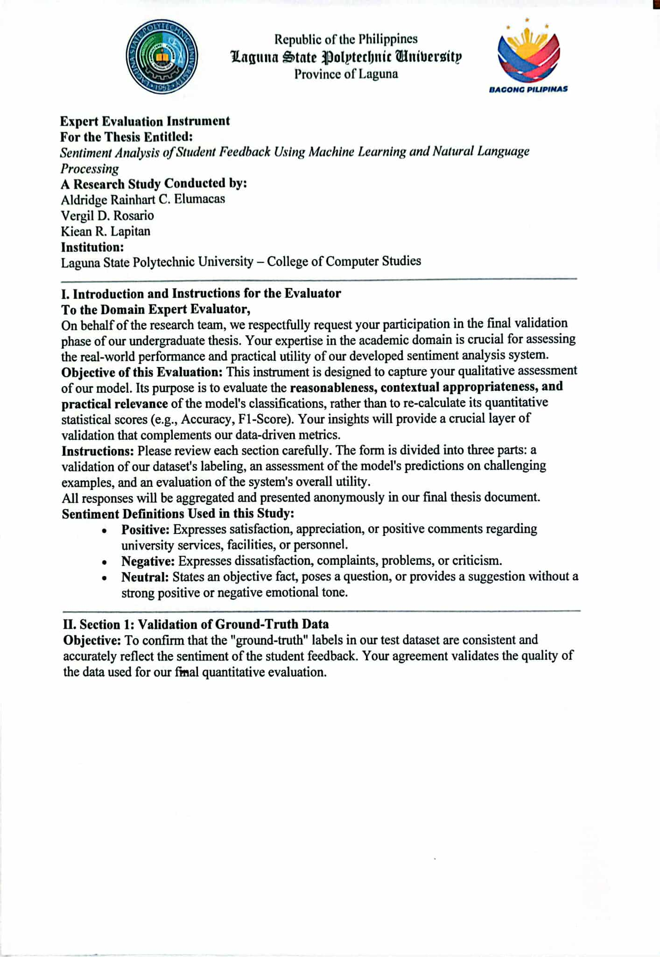

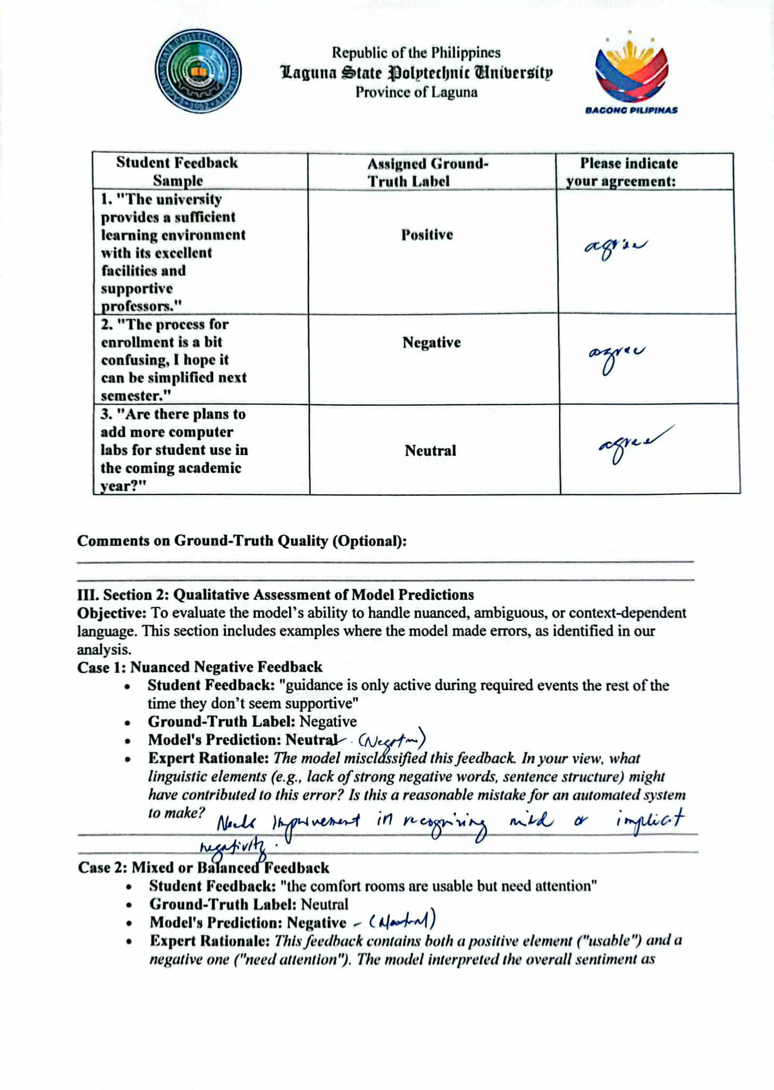
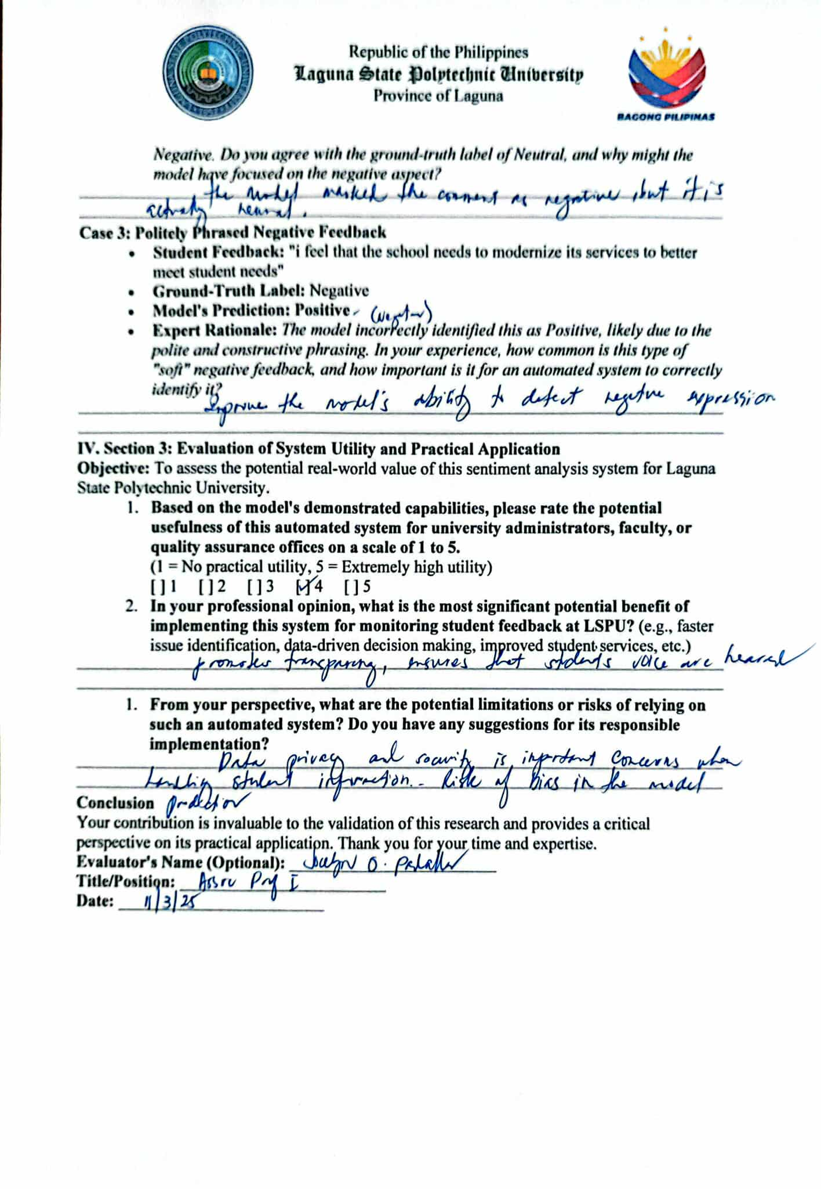

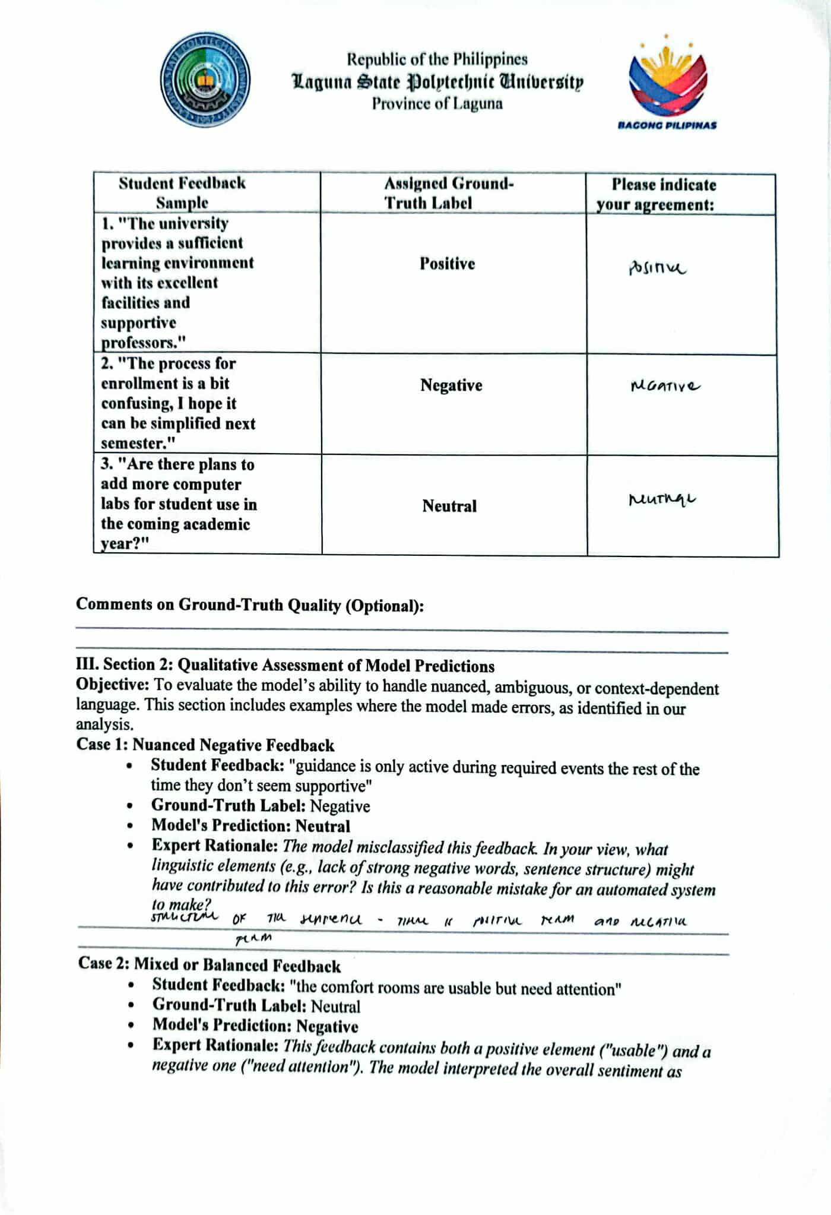

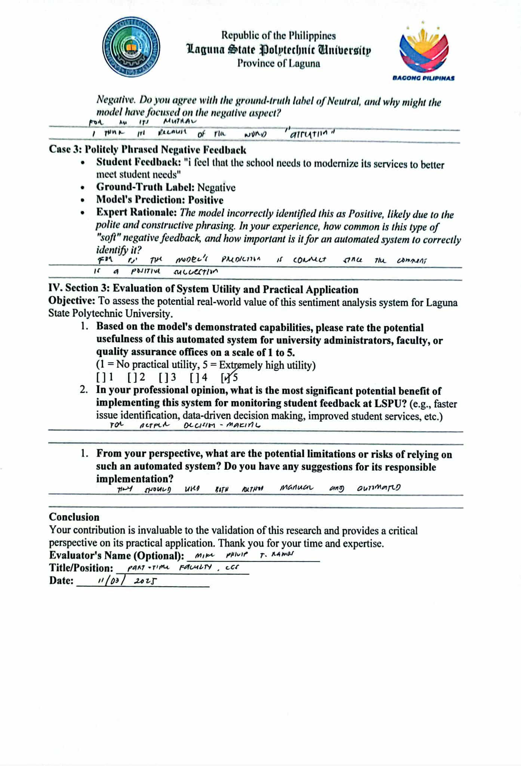

Appendix C
Survey Questionnaire

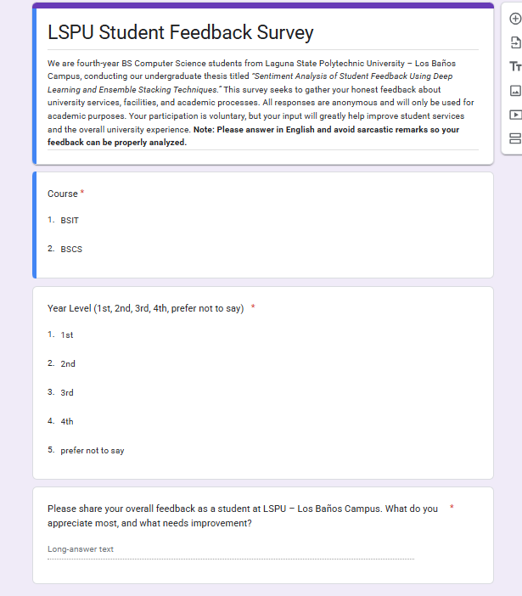
This survey questionnaire was created to collect feedback from students of LSPU – Los Baños Campus about their university experience. It gathers basic information such as course and year level, followed by an question that allows students to share what they appreciate most and what they think needs improvement. The responses provide insights into students’ opinions and emotions. The data gathered from this survey will serve as the dataset for training and evaluating our sentiment analysis model, enabling it to identify patterns in student feedback. Through this, the study aims to better understand student sentiments and provide useful insights that may help improve university services, facilities, and academic process.

Appendix D
CCS Population

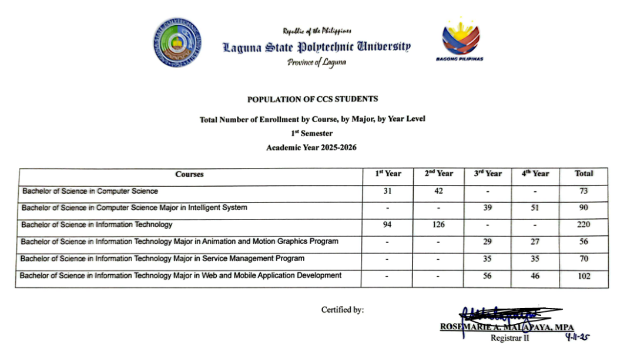

Appendix E
Relevant Source Code

class FocalLoss(torch.nn.Module):
def __init__(self, alpha=None, gamma=2.0, reduction='mean'):
super(FocalLoss, self).__init__()
self.alpha = alpha
self.gamma = gamma
self.reduction = reduction

def forward(self, inputs, targets):
ce_loss = F.cross_entropy(inputs, targets, reduction='none')
pt = torch.exp(-ce_loss)
focal_loss = (1 - pt) ** self.gamma * ce_loss
if self.alpha is not None:
focal_loss = self.alpha[targets] * focal_loss
return focal_loss.mean()

def standardize_and_clean_labels(df, label_col='label'):
df.dropna(subset=[label_col], inplace=True)

LABEL_MAPPING = {
'-1': 'negative', -1: 'negative',
'0': 'neutral', 0: 'neutral',
'1': 'positive', 1: 'positive'
}

df[label_col] = df[label_col].astype(str).map(LABEL_MAPPING)

original_len = len(df)
df.dropna(subset=[label_col], inplace=True)
new_len = len(df)

if original_len > new_len:
print(f" WARNING: Removed {original_len - new_len} rows with unexpected/invalid labels.")

return df

tokenizer, model, label_encoder = load_model_assets()
if tokenizer and model and label_encoder:
user_input = st.text_area(
"Enter student feedback here:",
height=150,
placeholder="e.g., 'The professors are very helpful and the library has great resources.'"
)

if st.button("Analyze Sentiment"):
if user_input.strip():

word_count = len(user_input.strip().split())

if word_count < MIN_WORDS:
st.warning(
f"⚠️ **Lack of Context** - The input has only {word_count} word(s). "
"Please provide more detail."
)
else:
with st.spinner("Analyzing..."):
predicted_label, confidence = predict_sentiment(
user_input, tokenizer, model, label_encoder
)

st.subheader("Analysis Result")

if predicted_label == 'positive':
st.success(
f"**Sentiment: Positive** 👍 ({confidence:.2%} confidence)"
)
elif predicted_label == 'negative':
st.error(
f"**Sentiment: Negative** 👎 ({confidence:.2%} confidence)"
)
else:
st.info(
f"**Sentiment: Neutral** 😐 ({confidence:.2%} confidence)"
)
else:
st.warning("Please enter some text to analyze.")
else:
st.header("Application is not ready.")
st.write(
"Could not load the machine learning model. "
"Please check the terminal for error messages."
)

Appendix F
Comparison of Fine-tuned and Ensembled

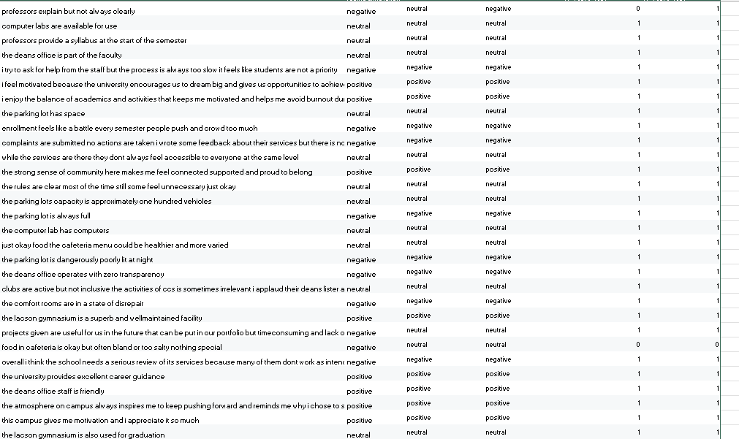
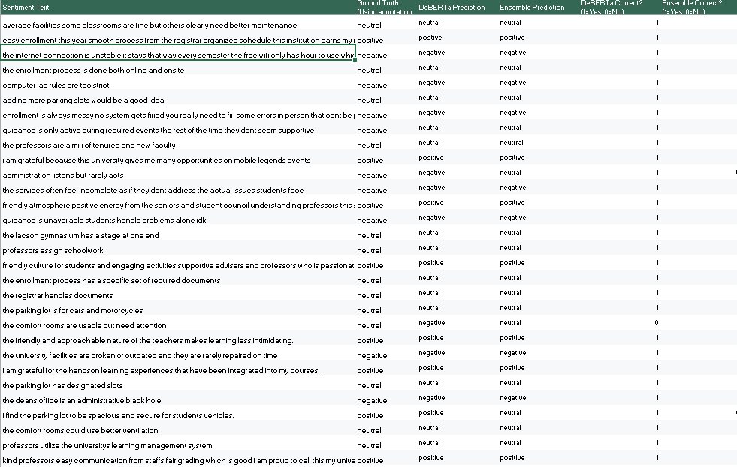

Appendix G
Ensemble Model Training Curve

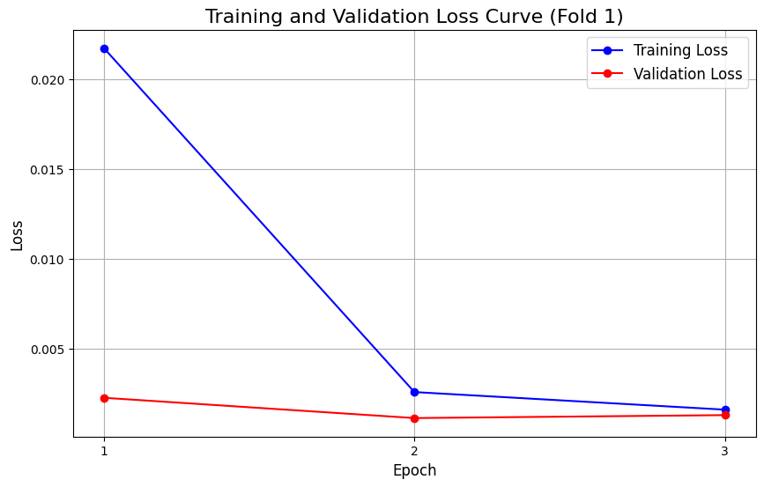
f
The graph shows that the training loss decreases significantly from Epoch 1 to Epoch 2, indicating that the model learns effectively during the early stages of training. The validation loss also decreases in this period, suggesting that the model generalizes well to unseen data.
From Epoch 2 to Epoch 3, the training loss slightly decreases while the validation loss slightly increases. This indicates a mild sign of overfitting, but the change is minimal and does not significantly affect model stability. Overall, the close trend between training and validation loss suggests good learning performance and effective generalization

Appendix H
Fine-Tuned Model Training Curve
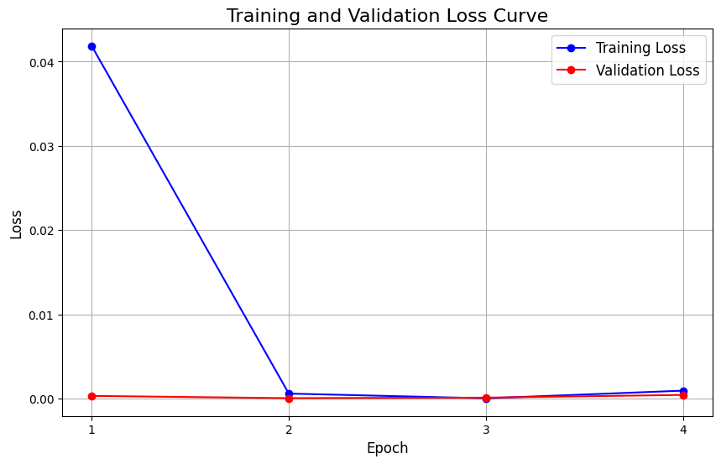
The training loss drops sharply from Epoch 1 to Epoch 2, showing that the model learns quickly and converges early while the validation loss remains very low and stable across all epochs, indicating strong generalization and consistent performance on unseen data.
A slight increase in both training and validation loss at the final epoch suggests a minor fluctuation, but it does not indicate significant overfitting. Overall, the results show that the model is well-trained, stable, and effectively balanced between learning and generalization.

Appendix I
User Manual

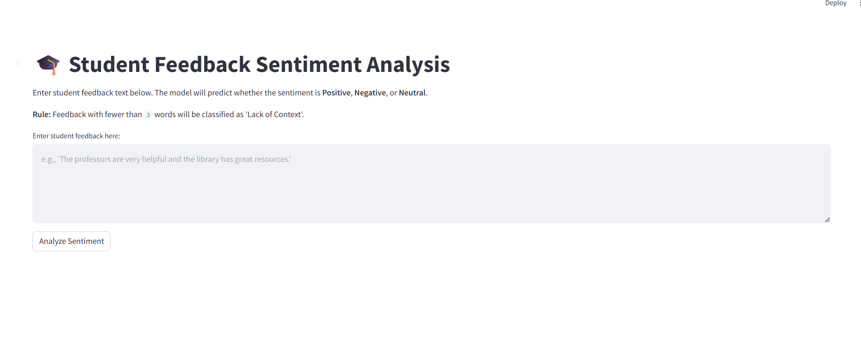
The Student Feedback Sentiment Analysis system is a simple web application that analyzes student feedback and determines whether the sentiment is Positive, Negative, or Neutral.
First, the system loads the required machine learning components: the tokenizer, the trained sentiment model, and the label encoder. These components allow the system to understand text, analyze it, and convert the results into readable sentiment labels. If any of this fail to load, the system will notify the user that the application is not ready.
The user enters student feedback into a text box provided in the interface. After typing the feedback, the user clicks the “Analyze Sentiment” button to start the analysis.
Before analysis, the system validates input, prompting entry if empty and issuing a lack-of-context warning for feedback under three words. Valid text is analyzed to predict sentiment, display confidence, and present positive, negative, or neutral results through appropriate messages clearly.

Appendix J
Curriculum Vitae





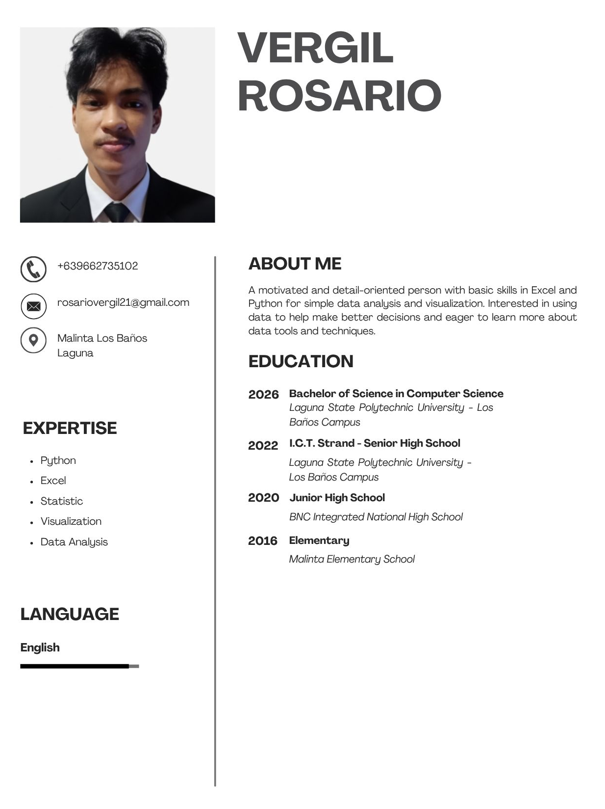

Appendix K
Publishable Paper (IEEE format)

SENTIMENT ANALYSIS OF STUDENT FEEDBACK USING MACHINELEARNING AND NATURAL
LANGUAGE PROCESSING
Aldridge Rainhart C. Elumacas, Vergil D. Rosario,
Kiean R. Lapitan, Maribel V. Cardona
College of Computer Studies (CCS), Laguna State Polytechnic University, Los Baños, Laguna, Philippines

Article Info |  | ABSTRACT
Article history:  Received: November 12, 2025  Revised: December 22, 2025  Accepted: January, 2026 |  | Sentiment analysis of student feedback plays a vital role in understanding learners’ perceptions and improving academic services. This study developed and evaluated a sentiment analysis system for classifying student feedback at Laguna State Polytechnic University–Los Baños Campus into positive, neutral, and negative categories using deep learning and natural language processing techniques. A total of 241 manually annotated student feedback responses were collected, pre-processed, and augmented to address data scarcity and class imbalance. A stratified train–test split was applied to preserve sentiment distribution. Two sentiment classification approaches were implemented: a fine-tuned DeBERTa transformer model and a stacked ensemble model composed of a K-Fold DeBERTa ensemble, Support Vector Machine, and LightGBM classifiers with Logistic Regression as the meta-classifier. Model performance was evaluated using accuracy, precision, recall, F1-score, confusion matrices, and statistical significance testing. The stacked ensemble model achieved an accuracy of 93.79%, demonstrating strong and balanced performance across all sentiment classes. Statistical analysis indicated that no significant difference in performance existed between the stacked ensemble and the fine-tuned DeBERTa model. Despite the slightly lower accuracy, the study recommended the use of the stacked ensemble model due to its robustness, complementary learning architecture, and reliability in capturing diverse sentiment patterns in localized educational feedback. These findings supported the applicability of ensemble-based approaches for data-driven decision-making in educational institutions.
Keywords: Sentiment Analysis, Natural Language Processing, Machine Learning, DeBERTa, Transformers, Stacked Ensemble, Student Feedback.
Corresponding Author:
Name: Aldridge Rainhart C. Elumacas, Vergil D. Rosario, Kiean R. Lapitan, Maribel V. Cardona
College of Computer Studies,
Laguna State Polytechnic University,
Malinta, Los Baños, Laguna, Philippines 4030.
Email: aldridge2524@gmail.com, rosariovergil21@gmail.com, kieanlapitan87@gmail.com

1. INTRODUCTION
Student feedback is an essential component of educational quality assurance, offering insight into teaching effectiveness, campus services, and overall student experience. However, manually analyzing large volumes of qualitative feedback is time-consuming, subject to bias, and often incapable of capturing nuanced sentiments. Recent advancements in Machine Learning (ML) and Natural Language Processing (NLP) have enabled automated and scalable text analysis tools capable of transforming unstructured text into actionable insights. Transformers—especially architectures
such as BERT and DeBERTa—have become state-of-the-art in sentiment analysis because of their ability to model linguistic context and semantic relationships. Prior research demonstrates that transformer-based models significantly outperform traditional ML techniques such as Naïve Bayes and SVM. Yet, ensemble methods remain relevant, as combining diverse models can capture different aspects of language and potentially improve robustness.
This study explores advanced sentiment classification for student feedback by developing and comparing two approaches: (1) a stacked ensemble model integrating multiple machine learning paradigms and (2) a single fine-tuned DeBERTa v3 model. The study further deploys the superior model in an interactive prototype that supports institutional decision-making...
2. Related Literature

Sentiment analysis has become a widely adopted tool for analyzing student feedback. Early works (Altrabsheh et al., 2014) explored traditional ML methods such as Naïve Bayes and SVM, demonstrating feasibility but limited contextual understanding. Deep learning advancements—particularly transformers—have reshaped NLP, with models like BERT surpassing classical algorithms in various benchmarks (Minaee et al., 2021).
DeBERTa specifically has shown strong improvements in educational sentiment tasks. Recent comparative studies (Koufakou, 2023) highlight DeBERTa's superior accuracy in course evaluation classification tasks. Meanwhile, literature on ensemble learning (Dietterich, 2000; Wolpert, 2020) establishes the theoretical advantages of combining diverse models, and recent NLP works have applied stacking to improve classification robustness.
In the Philippine context, challenges such as code-switching (Taglish), informal phrasing, and non-standard grammar complicate automated sentiment analysis (Roxas et al., 2018). Existing local research focuses heavily on social media data, revealing a gap in educational sentiment analysis systems built for Philippine institutions.

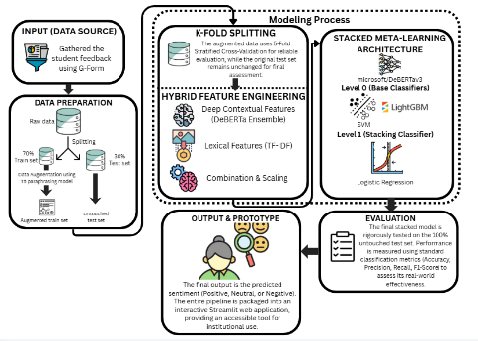

Figure 1. Conceptual Framework of the Study

3. METHODOLOGY
3.1 Study Area and Data Collection
This research was conducted at Laguna State Polytechnic University – Los Baños Campus (LSPU–LBC), specifically within the College of Computer Studies (CCS), which offers the Bachelor of Science in Computer Science and Bachelor of Science in Information Technology programs. The CCS was selected due to its high level of technological awareness and its alignment with the institution’s vision of fostering a smart and agile learning environment. Utilizing student feedback from a technology-oriented academic setting ensured that the sentiment analysis model was trained on domain-specific language relevant to institutional evaluation and data-driven decision-making.3.4 Data Collection, Preprocessing, Augmentation, and Validation Setup
3.2 Research Design
A quantitative experimental research design was adopted, focusing on the development, evaluation, and comparison of machine learning models for sentiment classification. The study emphasizes performance-based evaluation using standard classification metrics and does not aim to generalize findings beyond the dataset used. An applied systems development approach was employed to demonstrate the feasibility of deploying sentiment analysis in an academic institutional context.
3.3 Population and Sampling
The population of the study consisted of students enrolled in the College of Computer Studies at LSPU–LBC. A structured online survey was used to collect open-ended student feedback. All collected responses formed the complete dataset used for training, augmentation, and evaluation. The localized dataset ensured that the model was trained and validated within its intended operational context, enabling the transformation of unstructured feedback into actionable insights for institutional improvement, supporting data-driven decision-making, academic quality assurance, and continuous service enhancement.
3.3 Data Collection
Student feedback was collected through an online survey consisting of open-ended questions that allowed respondents to freely express their opinions regarding academic experiences and institutional services. All responses were anonymized to ensure confidentiality and ethical compliance.

3.4 Dataset Description

The dataset consisted of 241 manually annotated student feedback entries labeled as positive, neutral, or negative. Annotation was performed following predefined sentiment guidelines to ensure consistency. The dataset exhibited natural class imbalance, with positive and neutral sentiments occurring more frequently than negative ones. After cleaning and validation, all 241 entries were retained. A stratified 70/30 train-test split was applied, resulting in 169 training samples and 72 test samples.

3.5 Data Preparation and Pre-Processing

Data preprocessing was applied only to the training set to prevent information leakage. The steps included text normalization, T5-based data augmentation, and feature preparation. Contextual features were generated using the DeBERTa v3 tokenizer with a maximum sequence length of 128 tokens, covering approximately 95% of feedback lengths. Stop-word removal was intentionally omitted to preserve contextual information. Lexical features were extracted using a TF-IDF vectorizer to represent word and n-gram importance. Data augmentation was applied to underrepresented classes using a T5-based paraphrasing model to address class imbalance.
3.6 Model Architecture
1. Fine-Tuned DeBERTa Baseline Model: A single DeBERTa transformer model fine-tuned on the training dataset to serve as a strong baseline.
2. Stacked Ensemble Model: A stacked generalization architecture integrating a K-Fold DeBERTa ensemble, Support Vector Machine (SVM), and LightGBM as base learners. Their predictions were combined using a Logistic Regression meta-classifier to improve robustness and generalization

Figure 2: Architecture Diagram

3.7 Training Procedure

Model training followed a standardized procedure to ensure reproducibility. A stratified 5-Fold cross-validation strategy was employed for the base learners to generate out-of-fold predictions. The DeBERTa models were fine-tuned using Focal Loss to mitigate class imbalance and Early Stopping to prevent overfitting. Classical machine learning models (SVM and LightGBM) were trained on hybrid features combining contextual and lexical representations. The final Logistic Regression meta-classifier was trained using base-learner predictions as input features.
3.8 Hyperparameter Configuration

Key hyperparameters were documented to ensure transparency and reproducibility. DeBERTa utilized the AdamW optimizer with a learning rate of 2e-5, batch size of 16, and weight decay of 0.01. SVM employed an RBF kernel with optimized regularization parameters, while LightGBM used gradient boosting with 200 estimators. The meta-classifier applied L2-regularized Logistic Regression.

3.9 Evaluation Metrics and Validation
Model performance was evaluated using accuracy, precision, recall, and F1-score. Confusion matrices were generated to analyze misclassification patterns. To assess the statistical significance of performance differences between the baseline and ensemble models, paired t-tests and McNemar’s tests were conducted at a significance level of α = 0.05.

3.10 System Implementation
The final model was deployed as a Streamlit-based web application to demonstrate real-time sentiment analysis. The system integrates all trained components, including the TF-IDF vectorizer, DeBERTa ensemble, SVM, LightGBM, and Logistic Regression meta-classifier. The interface enables institutional stakeholders to analyze student feedback efficiently and supports data-driven decision-making.
3.11 Ethical Considerations

Ethical standards were strictly observed throughout the study. Informed consent was obtained from all participants, and all data were anonymized to protect privacy. The dataset was securely stored and used solely for academic research purposes.

3.12 Limitations

The study is limited by its localized dataset, which may restrict generalizability to other academic departments. Additionally, sentiment classification was limited to three broad categories and did not capture nuanced emotional states. The computational cost of the stacked ensemble also limits scalability, positioning the system as a proof-of-concept rather than a fully optimized production solution.

4. RESULTS AND DISCUSSION
This study developed and evaluated a sentiment analysis system for classifying student feedback at Laguna State Polytechnic University–Los Baños Campus using deep learning and natural language processing. Manually annotated feedback was labelled as positive, neutral, or negative, and two models were implemented: a fine-tuned DeBERTa transformer and a stacked ensemble of transformer-based and classical classifiers. After pre-processing, augmentation, and stratified splitting, evaluation results showed DeBERTa outperformed the ensemble, while error analysis revealed challenges in handling polite criticism and mixed sentiments.
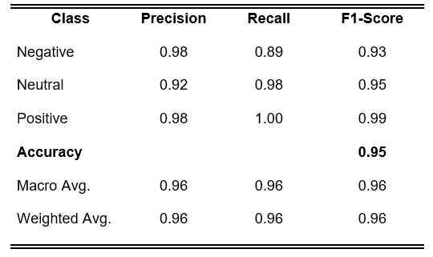
Table 1: Classification Report for the Baseline (Fine-tuned DeBERTa) Model

McNemar’s Test revealed statistically significant improvement of the DeBERTa baseline over the ensemble (p < 0.05).
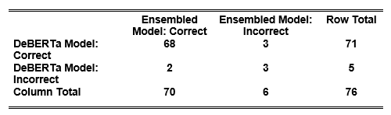
Table 2: McNemar’s Test Contingency Table
A Streamlit-based sentiment analysis interface was developed, demonstrating real-time predictions, confidence visualization, and potential integration into institutional systems.

5. SUMMARY, CONCLUSIONS, AND RECOMMENDATIONS
5.1 Summary of the Study
This study developed and evaluated a sentiment analysis system for classifying student feedback at Laguna State Polytechnic University–Los Baños Campus into positive, neutral, and negative categories using machine learning and natural language processing techniques. A localized dataset of 241 manually annotated student feedback responses was collected, pre-processed, and augmented to address class imbalance and data scarcity, with a stratified train–test split applied for unbiased evaluation. Two modelling approaches were implemented: a fine-tuned DeBERTa transformer baseline and a stacked ensemble model combining a K-Fold DeBERTa ensemble, Support Vector Machine, and LightGBM classifiers with Logistic Regression as a meta-learner. Model performance was assessed using accuracy, precision, recall, F1-score, confusion matrices, and statistical significance testing. The stacked ensemble achieved an accuracy of 93.79% and demonstrated balanced performance across all sentiment classes, while statistical analysis indicated no significant difference between the ensemble and the fine-tuned transformer model. Despite slightly lower accuracy, the stacked ensemble was recommended due to its robustness, complementary learning architecture, and reliability in capturing diverse sentiment patterns in localized educational feedback, supporting its applicability for data-driven decision-making in higher education.5.1 Recommendations
To further strengthen and expand the applicability of the proposed sentiment analysis system, several key recommendations are suggested. First, the dataset should be expanded across more colleges, campuses, and academic years to improve model robustness and reduce risks of overfitting. Future research may also integrate Aspect-Based Sentiment Analysis (ABSA) to generate more granular insights on specific areas such as instructors, curriculum, facilities, and services. Considering the prevalence of Tagalog–English code-switching among Filipino students, developing multilingual or Taglish-optimized models is also essential for capturing local linguistic patterns more accurately. System deployment may be enhanced by implementing a real-time analytics dashboard capable of visualizing sentiment trends and summaries for
administrative decision-making. The ensemble architecture may likewise be improved by experimenting with neural meta-learners, weighted voting schemes, or hybrid transformer–traditional pipelines. Conducting longitudinal sentiment analysis is recommended to identify changes in student perceptions over time and guide policy formulation. Additionally, integrating the system into Learning Management Systems (LMS) such as Moodle, Canvas, or Google Classroom would allow automated and scalable feedback monitoring. To improve transparency, explainability techniques such as SHAP, Integrated Gradients, or attention heatmaps should be incorporated to help administrators interpret model outputs. Further enhancements to the prototype—including batch processing, administrative dashboards, and exportable reports—can increase usability. Finally, evaluating model deployment on edge or mobile platforms through optimization and compression techniques would support broader accessibility, particularly in low-resource or offline environments.
REFERENCES
[1] Shaik, S. A., Alghamdi, A. A., & Alzahrani, A. A. (2022). Sentiment analysis and opinion mining on educational data: A survey. Education and Information Technologies, 27(1), 1–24. https://doi.org/10.1016/j.eait.2022.01.003
[2] Kastrati, Z., Dalipi, F., Imran, A. S., Pireva Nuci, K., & Wani, M. A. (2021). Sentiment analysis of students’ feedback with NLP and deep learning: A systematic mapping study. Applied Sciences, 11(9), 3986. https://doi.org/10.3390/app11093986
[3] Dai, J., Chen, H., & Li, Y. (2019). A backdoor attack against LSTM-based text classification systems. 2019 IEEE International Conference on Acoustics, Speech and Signal Processing (ICASSP), 6365–6369. https://doi.org/10.1109/ICASSP.2019.8763969
[4] Pooja, & Bhalla, R. (2022). A review paper on the role of sentiment analysis in quality education. SN Computer Science, 3(6), 469. https://doi.org/10.1007/s42979-022-01366-9
[5] Sweta, S. (2024). The transformative role of sentiment analysis in education. In Sentiment Analysis and its Application in Educational Data Mining (pp. 47–60). Springer. https://doi.org/10.1007/978-981-97-2474-1_3
[6] Zhou, Y., & Li, Y. (2022). A hybrid deep learning model for sentiment analysis based on improved attention mechanism. Expert Systems with Applications, 207, 117979. https://doi.org/10.1016/j.eswa.2022.117979
[7] Kounte, M. R., Tripathy, P. K., Pramod, P., & Bajpai, H. (2020). Analysis of intelligent machines using deep learning and natural language processing. In Proceedings of the Fourth International Conference on Trends in Electronics and Informatics (ICOEI 2020) (pp. 956–961). IEEE. https://doi.org/10.1109/ICOEI48184.2020.9142996
[8] Kastrati, Z., Dalipi, F., Imran, A. S., Pireva Nuci, K., & Wani, M. A. (2021). Sentiment analysis of students’ feedback with NLP and deep learning: A systematic mapping study. Applied Sciences, 11(9), 3986. https://doi.org/10.3390/app11093986
[9] Khan, T., Shah, S. A. R., & Khan, K. H. (2016). Sentiment analysis and the complex natural language. Complex Adaptive Systems Modeling, 4(1), 2. https://doi.org/10.1186/s40294-016-0016-9
[10] Garimella, K., De Francisci Morales, G., Gionis, A., & Mathioudakis, M. (2016). Quantifying controversy on social media. Proceedings of the Tenth International AAAI Conference on Web and Social Media, 10(1), 52–61. https://ojs.aaai.org/index.php/ICWSM/article/view/14157/14006
[11] Altrabsheh, N., Gaber, M. M., & Cocea, M. (2013). SA-E: Sentiment Analysis for Education. 5th KES International Conference on Intelligent Decision Technologies, 3, 1–10. https://impacterpathway.com/wp-content/uploads/2023/11/Sentiment-Analysis-For-Education.pdf
[12] Misuraca, M., van Noordt, C., & Boukli, A. (2022). Sentiment analysis and opinion mining on educational data: A systematic review. Discover Artificial Intelligence, 2(1), 3. https://doi.org/10.1016/j.discai.2022.100003
[13] Misuraca, M., Forciniti, A., Scepi, G., & Spano, M. (2020). Sentiment analysis for education with R: Packages, methods and practical applications. arXiv preprint arXiv:2005.12840. https://arxiv.org/abs/2005.12840Academia+6arXiv+6Papers with Code+6
[14] Hajrizi, R., & Pireva Nuçi, K. (2020). Aspect-based sentiment analysis in education domain. arXiv preprint arXiv:2010.01429. https://arxiv.org/abs/2010.01429
[15] Torfi, A., Shirvani, R. A., Keneshloo, Y., Tavaf, N., & Fox, E. A. (2021). Natural language processing advancements by deep learning: A survey. arXiv preprint arXiv:2003.01200. https://arxiv.org/abs/2003.01200
[16] Young, T., Hazarika, D., Poria, S., & Cambria, E. (2018). Recent trends in deep learning based natural language processing [Review article]. IEEE Computational Intelligence Magazine, 13(3), 55–75. https://ieeexplore.ieee.org/abstract/document/8416973
[17] Houssein, E. H., Mohamed, R. E., & Ali, A. A. (2023). Heart disease risk factors detection from electronic health records using advanced NLP and deep learning techniques. Scientific Reports, 13, Article 7173. https://doi.org/10.1038/s41598-023-34294-6
[18] Kumar, S., Anand Kumar, M., & Soman, K. P. (2019). Deep learning-based part-of-speech tagging for Malayalam Twitter data. Journal of Intelligent Systems, 28(3), 423–435. https://doi.org/10.1515/jisys-2017-0520
[19] Sharifani, K., & Amini, M. (2023). Machine learning and deep learning: A review of methods and applications. World Information Technology and Engineering Journal, 10(7), 3897–3904. https://papers.ssrn.com/sol3/papers.cfm?abstract_id=4458723
[20] Poomka, P., Kerdprasop, N., & Kerdprasop, K. (2021). Machine learning versus deep learning performances on the sentiment analysis of product reviews. International Journal of Machine Learning and Computing, 11(2), 103–109. https://doi.org/10.18178/ijmlc.2021.11.2.1021

Appendix L
Plagiarism Checker

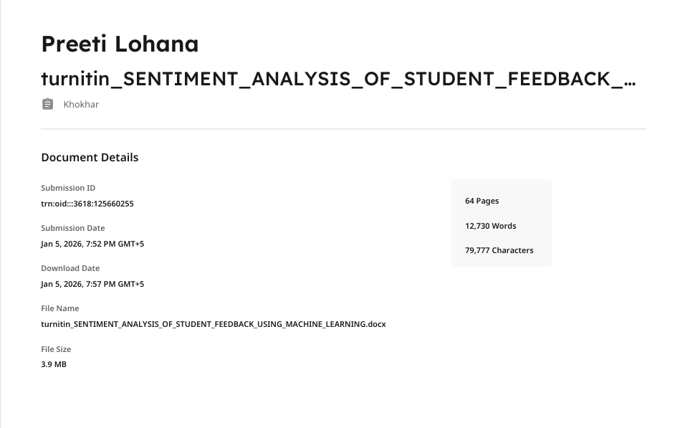
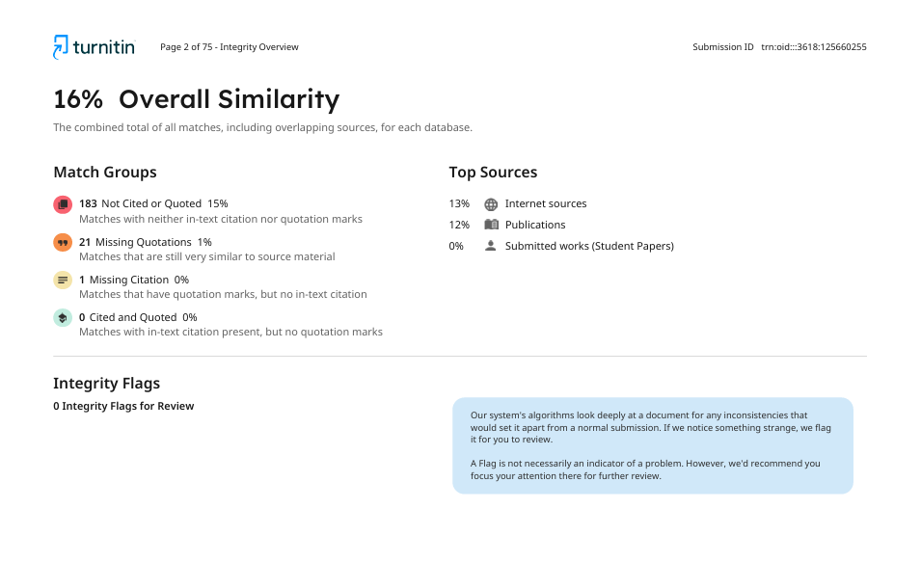

Appendix M
Grammar Checker

